Abstract for SPIE Medical Imaging 2008

Integration of a real-time video capturing functionality to IGSTK

Ole Vegard Solberg 1, 2), Geir-Arne Tangen 1), Frank Lindseth 1), Kevin Cleary 3), …

1) SINTEF Health Research, Medical Technology, Trondheim, Norway
2) Norwegian University of Science and Technology (NTNU), Faculty of Medicine; Department of Circulation and Medical Imaging, Trondheim, Norway
3) Imaging Science and Information Systems (ISIS) Center, Department of Radiology,
Georgetown University Medical Center, Washington, DC, 20007, USA

Abstract
The image guided surgery toolkit (IGSTK) [1] is an open source C++ library that provides basic components required for developing image-guided surgery applications. Currently, the project is in phase III and new components are being added. One of the componets which is currently under development is the video grabber component. The video grabber component captures video stream and makes it available to the rest of the IGSTK components. This is particularly very useful to import intraoperative data during an image guided surgery procedure. Intraoperative data includes such as 2D/3D ultrasound data and video data from endoscopic camera. The correct placement of the video stream with respect an interaction with the IGSTK tracker component is necessary, and the visualization is again dependant of existing and future visualization components of IGSTK. This paper describes the video grabber component design and presents example applications using the video grabber component. Designing the video grabber component involves considering several requirements. Interaction with existing and future IGSTK components and internal state machine design are the main considerations.

Keywords: Image-guided surgery, Intraoperative imaging

Purpose
For the benefit of the patient, systems for image-guided minimal invasive surgery and therapy are increasingly being used in order to safely navigate surgical instruments inside the human body. An indication of the location of a tool is overlaid medical images (CT, MR, ultrasound, etc.) in much the same way as modern GPS systems in cars are working. It is therefore paramount that the medical images show an accurate picture of the current patient anatomy. Ideally, this would be an intraoperative real-time 3D image map taking things like respiration, pulsation and surgical manipulation into account. The previous versions of IGSTK have been based solely on preoperative data. The new video grabber component will allow the import of an intraoperative video stream into IGSTK. For creating a component for import of intraoperative data into IGSTK, the most obvious design choice is to import an analog video stream. Currently no digital standards exist, and an analogous video grabber allows integration with all kinds of video equipment. This video stream may thus consist of 2D ultrasound data or other video sources such as endoscopy video. Imported 2D ultrasound may be presented relative to other imaging modalities, such as pre-operative CT or MR, or be processed further into 3D ultrasound [2]. The presentation and processing of the imported video is naturally dependent on the other IGSTK components. The video grabber component is one of several important steps in making IGSTK a complete toolkit for image guided surgery. Currently the video grabber component is being developed by SINTEF, a Norwegian research foundation.

Methods
The new video grabber component is based on the following list of requirements:
- Import real-time video without noticeable delay.
- Allow synchronization with other components.
- Support cross platform development. Goal is cross platform support (but not necessarily all platforms at once).
- Make sure the component works with hardware used by the IGSTK partners.
- Grab video stream or grab single image.
- Handle multiple input streams.
- Support different video input standards.
- Support different video output formats.
- Support buffering of video stream for later processing (ultrasound 3D reconstruction etc.)

In the design phase, the interaction of the video grabber component with other IGSTK components has to be (Figure 1) streamlined. Platform specific classes of the video grabber components will be designed (Figure 2). The next step is designing a framework for the component based on the IGSTK state machine. After the design stage the implementation stage starts by first implementing the state machine framework, implementinl the code, ast writing various tests to ensure that the code performs as expected.

Results
The video grabber component will in collaboration with the other existing and future IGSTK components allow access to real-time data in the operation room. This data could be combined with preoperative data, such as CT and MR images. The first use case of the video grabber component will be to import a 2D ultrasound data into IGSTK. The ultrasound probe has to be calibrated first to register the probe with the ultrasound image pixel location. During surgery, the pre-operative data is first registered to the patient, and then the ultrasound is imported into this patient-registered coordinate system using the registration component of IGSTK. The ultrasound data can be presented in different ways:
- A 2D presentation in a 2D view.
- A 2D presentation in a 3D view. See example in Figure 3.
- As 3D reconstructed ultrasound volume.

All presentations could be combined with preoperative data in several possible ways. An example is a 2D slice through a reconstructed 3D ultrasound volume following a surgical tool, combined with a 3D preoperative volume. This allows the use of the most recent data during surgery while still showing the preoperative data as an orientation support. Visualization of the imported real-time data in IGSTK will require implementation of additional support objects for the imported data, such as spatial object and spatial object representation. In addition, it may be necessary to implement both volume rendering and multiple volume visualization to allow full use of the data.

Conclusions
It is feasible to integrate real-time data into IGSTK with the purpose of providing more relevant data during surgery. IGSTK, as an open source project allows outside resources to develop necessary components, while supplying a structure to allow for development of robust code. IGSTK has the potential of becoming an excellent toolkit for fast creation of safe image-guided surgery applications.

Statement
The manuscript, or specific parts of it, has not been submitted elsewhere for publication.

References
- C. Peng, Z. Hui, K. Hee-su, G. Kevin, M. B. Blake, G. David, A. Stephen, J. Julien, E. Andinet, A. Rick, I. Luis, and C. Kevin, "IGSTK: Framework and example application using an open source toolkit for image-guided surgery applications," in SPIE, vol. 6141, R. C. Kevin, L. G. Robert, and Jr, Eds.: SPIE, 2006, pp. 61411Y.
- O. V. Solberg, F. Lindseth, H. Torp, R. E. Blake, and T. A. N. Hernes, "Freehand 3D Ultrasound Reconstruction Algorithms--A Review," Ultrasound in Medicine & Biology, vol. 33, pp. 991-1009, 2007.

Figures

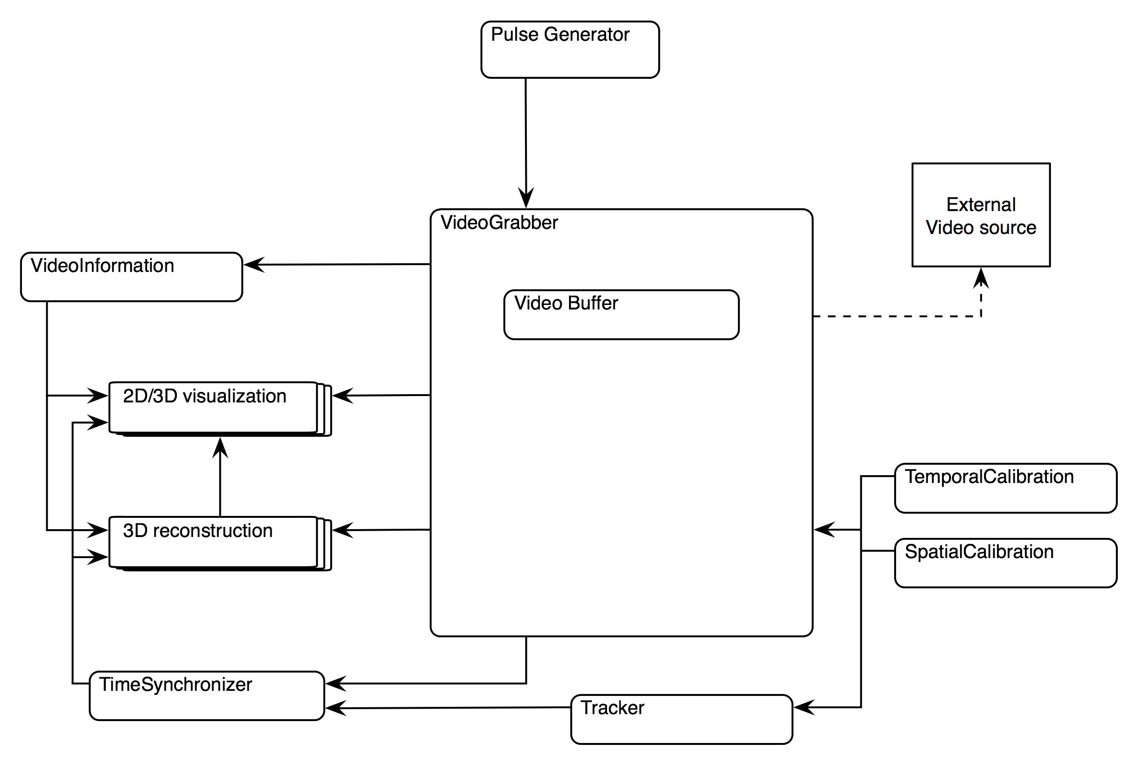
Figure 1: Overview of the video grabber component

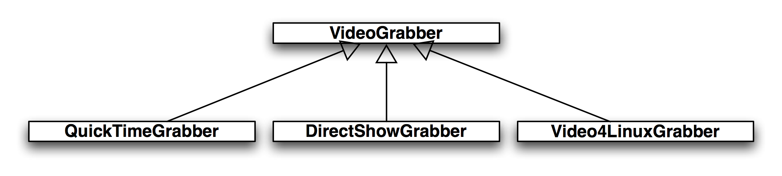
Figure 2: The video grabber component, class diagram
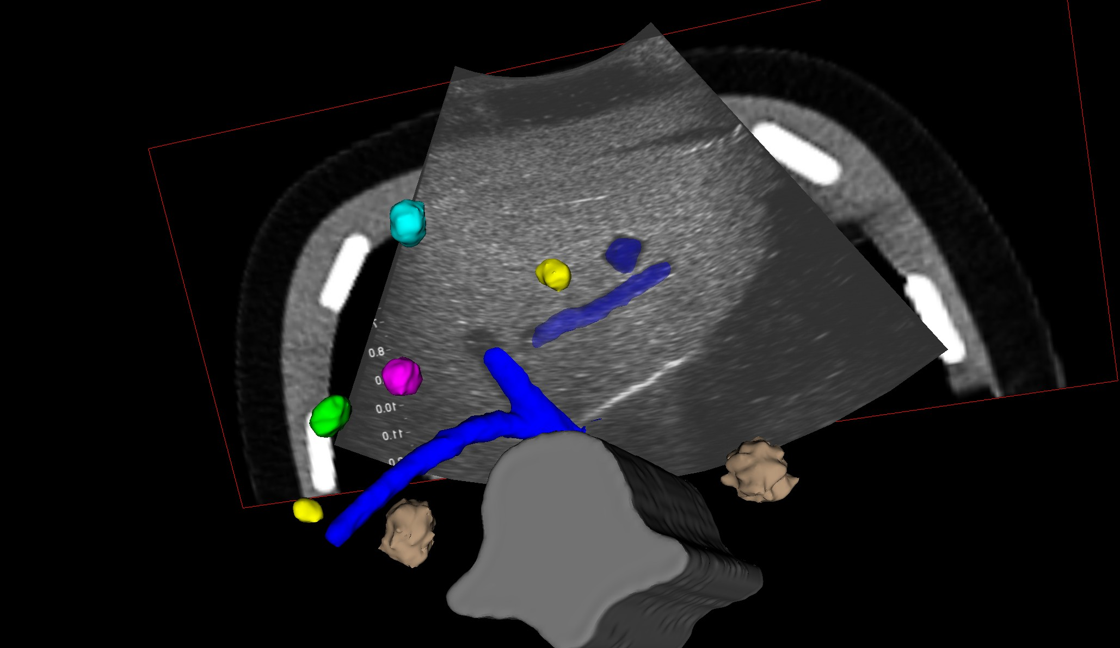
Figure 3: 3D scene with 2D ultrasound, 2D CT and 3D segmented objects from CT

