Research Plan
Continued Development for The Image-guided Surgical Toolkit Project (IGSTK)

Specific Aims
The goal of this proposal is to continue to develop, maintain, test, and evaluate the Image-Guided Surgical Toolkit (IGSTK). IGSTK is an open source software project which provides the basic components to develop an image-guided system. The initial version of the software was released to the public in February 2006 at the SPIE Medical Imaging Conference in San Diego and we have received good feedback from the user community. The software is currently available on the IGSTK web site for free download by any interested party under the BSD open source license. The software was developed under a Phase II STTR grant over the last two years.
This proposal is a partnership that includes all of the original developers on the project. The principal investigator is Kevin Cleary, PhD, of Georgetown University (Washington, DC), who served as the PI on the STTR project. The commercial partner and key development group is Kitware, Inc. (Clifton, New York), a small business specializing in open-source software. Expertise in tracking systems and developing image-guided applications is provided by Atamai, Inc. (Ontario, Canada). Experience in software project management and object-oriented developed is supplied by Arizona State University.
The specific aims of the research are to:
- Support the user community of the IGSTK project by responding to email requests, fixing bugs, and holding an annual user’s meeting at the SPIE Medical Imaging conference
- Extend the existing software by incorporating:
  - {please suggest}
  - {please suggest}
  - {please suggest}
- Develop an application template and programming guide to make it easy for new user to develop applications using the toolkit
- Develop a clinical application for image-guided lung biopsy and pursue FDA and IRB approval for a clinical trial {do we need this fourth aim?}
This research effort will require a multi-disciplinary team approach. The key team members are:
- Kevin Cleary, PhD, the principal investigator and a medical researcher at Georgetown with extensive experience in developing image-guided systems for the interventional environment.
- Thinking about listing Luis, Rick, Stephen, David, K2, maybe one clinical person??

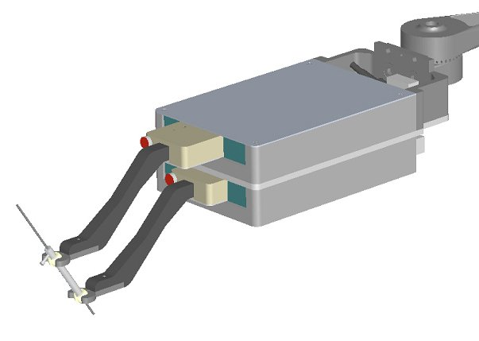
Figure 1: this is the deck of cards robot which we have at Georgetown and was built by my Austrian friend. It is very low profile and could serve as a needle guide. One problem is that it becomes a rigid needle guide.
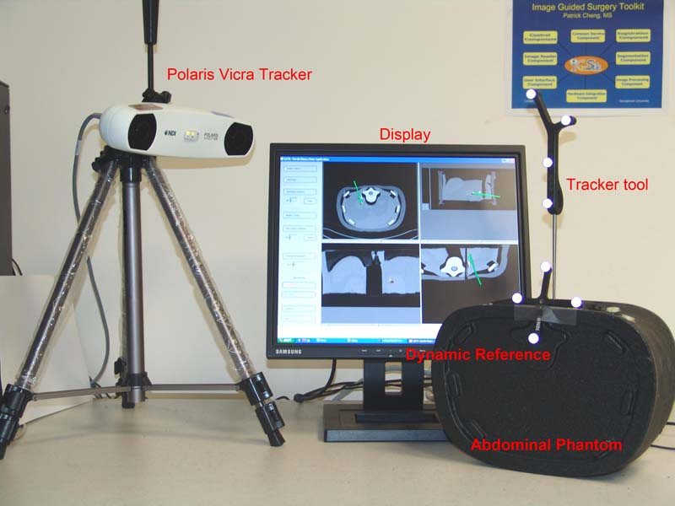

Figure 2: here is the image-guided demo system from the SPIE Medical Imaging conference last week.

