IGSTK: Framework and Example Applications Using an Open Source Toolkit for Image-Guided Surgery Applications

Kevin Clearyª*, Patrick Chengª, James Zhangª, Hee-su Kim^{b}, Kevin Gary^{c}, M. Brian Blake^{d}, David Gobbi^{e}, Stephen Aylward^{f}, Julien Jomier^{f}, Andinet Enquobahrie^{f}, Rick Avila^{f}, Luis Ibanez^{f}
ªImaging Science and Information Systems (ISIS) Center, Dept. of Radiology,
Georgetown University, Washington, DC, USA
^{b}{ask Hee-su for present affiliation}, Korea
^{c}Division of Computing Studies, Arizona State University, Mesa, Arizona, 85212, USA
^{d}Department of Computer Science, Georgetown University, Washington, DC, 20007, USA
^{e}Atamai Inc., London, Ontario, N6B 2R4, Canada
^{f}Kitware Inc., Clifton Park, NY, 12065, USA

ABSTRACT

{to complete at end}.

Keywords: open source, surgical guidance, tracking, state machine {need 2 to 4 others}

1. PURPOSE

1.1 First first level subheading if needed
The field of image-guided surgery is rapidly expanding, as image-guided surgical techniques are being developed that minimize treatment invasiveness and thereby reduce trauma and speed recovery for patients. A typical image-guided system consists of tracking subsystems for capturing the movement of instruments and the patient and a computer subsystem for integrating and displaying pre- and inter-operative images and instrument positions using the tracking data. The software of the computer subsystem usually requires the majority of the development effort. As new trackers and data integration algorithms are developed, each research group must develop its own image-guided system, which can be a time-consuming undertaking. Testing such systems can also be an extensive process, with risks to patients and surgeons. The purpose of the image-guided surgery toolkit is to enable robust image-guided software to be easily created and validated as open-source software, free of commercial licensing restrictions.

1.2 Second first level subheading if needed

2. METHODS

The software toolkit has been under development for nearly one year and a public beta release will be available by the time of the conference, Feburary 2006. Robustness and quality have been the highest priority in the design of the toolkit, which is based on the following existing opening source components: ITK for segmentation and registration, VTK for visualization, and FLTK for the user interface. The toolkit contains the basic software components to construct an image-guided system, including a support for trackers, data integration algorithms, and a four-quadrant view incorporating image overlay.

Figure 1 presents a UML collaboration diagram of the major IGSTK components involved in a typical image-guided surgery application. The key components are from left to right:
- View class for presenting results and displays to the physician
- SpatialObjects class models physical objects including image data and simple geometrical shapes
- SpatialObjectRepresentation class provides connection between SpatialObjects & View classes
- Tracker class to store data from localizers (trackers)

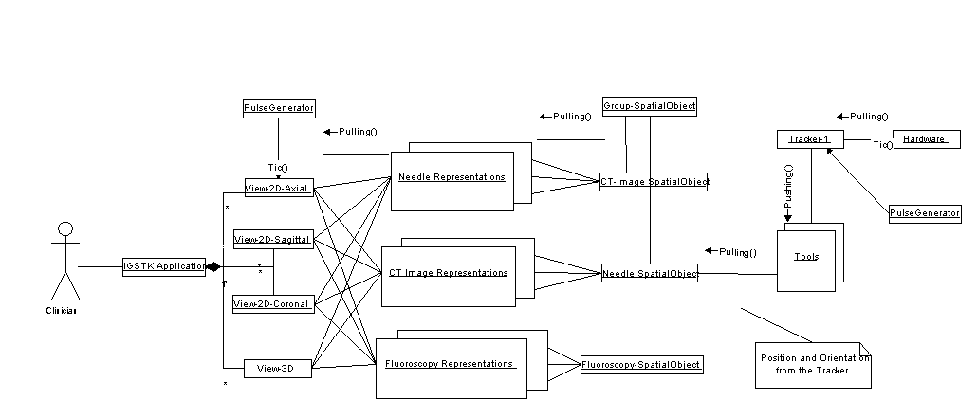
IGSTK Application Viewers Spatial Object Spatial Objects Tracker
Representations

Figure 1: IGSTK Component Architecture {this is most recent figure: from IEEE Computer paper dec 2005}

The toolkit was implemented using a state machine paradigm. The state machine make the deterministic behavious of the system explicit. State machine also encapsulates for easy extension.

3. RESULTS

The major components of the toolkit have been completed and we are beginning to create example applications using the toolkit. Automated nightly testing… Code coverage on tests is 100%. State machine allows automated testing of applications developed using the toolkit. Demonstrate application for RFA is being delivered…

4. CONCLUSIONS

Open source software has tremendous potential for improving the productivity of research labs and enabling the development of new medical applications. The image-guided software toolkit (IGSTK) should enable researchers to quickly build robust image-guided applications and enable the development of new image-guided techniques.

ACKNOWLEDGMENTS

This research is supported by the National Institute of Biomedical Imaging and Bioengineering (NIBIB) at the National Institutes of Health (NIH) under grant R42EB000374 and by U.S. Army grant W81XWH-04-1-0078. The content of this manuscript does not necessarily reflect the position or policy of the U.S. Government. The authors would like to thank the IGSTK advisory board for their advice throughout the project: Will Schroeder of Kitware; Ivo Wolf of the University of Heidelberg; Peter Kazanzides and Anton DeGuet from John Hopkins University; and Ingmar Bitter, Matt McAuliffee, and Terry Yoo from the NIH.

REfereNCES

{to be completed}

* cleary@georgetown.edu; Telephone 1-202-687-8253; Fax 1-202-784-3479

