IGSTK: An Image-Guided Software Toolkit
for Open Source Surgical Application Development

Kevin Gary1, M. Brian Blake², Luis Ibanez3, David Gobbi4, Stephen Aylward3, and Kevin Cleary6
1 Division of Computing Studies, Arizona State University, Mesa, Arizona, 85212, USA
kgary@asu.edu
2 Department of Computer Science, Georgetown University, Washington, DC, 20007, USA
blakeb@cs.georgetown.edu
3 Kitware Inc., Clifton Park, NY, 12065, USA
luis.ibanez@kitware.com, stephen.aylward@kitware.com
4 Atamai Inc., London, Ontario, N6B 2R4, Canada
dgobbi@atamai.com

5 Imaging Science and Information Systems (ISIS) Center, Department of Radiology, Georgetown University Medical Center, Washington, DC, 20007, USA
cleary@georgetown.edu

Image-Guided Surgery

Introduction and Background

The Image-Guided Software Toolkit (IGSTK: pronounced IGstick) is an open source project aimed at supporting the development of reliable software for patient-critical medical applications, particularly image-guided surgery applications. In its broadest sense, image-guided surgery involves the use of medical images to provide instrument guidance and for clinical decision making during minimally invasive procedures. Specifically, image-guided surgery systems, also known as computer-aided surgery systems, have been developed to provide the physician with a virtual, real-time display of the anatomy located in the region of a surgical instrument. The typical display is composed of a combination of anatomical images acquired before the surgical intervention, graphical representations of the surgical instruments, and also sometimes includes intra-operative image updates of the anatomy.

To display the location of surgical instruments with respect to the patient’s anatomy, the relative location of the instrument and the patient is measured using devices known as trackers. Trackers thus allows display of the instrument location on a pre-operative or intra-operative medical image showing the anatomy of interest. This display can help guide the physician to the precise anatomical target and also provides the physician with a type of “x-ray vision” in that the physician can see what lies beneath a surgical instrument before moving the instrument. A typical image-guided surgery system for brain surgery is shown in Figure 1.

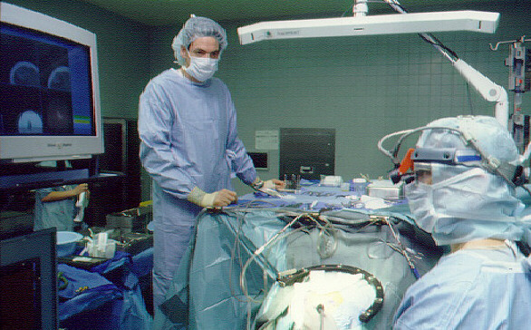

Figure 1: Image-guided system for brain surgery showing the patient (under the blue cover in front), the physicians, the optical tracking system, and the display overlay (courtesy of Richard Bucholz, MD, St. Louis University).

Image-guided surgical procedures usually mean substantially less trauma for the patient. Image guidance was originally developed for neurosurgical applications as navigation in the brain requires great precision (Watanabe, 1987). This technology allows the physician to use pre-operative computed tomography (CT) or magnetic resonance imaging (MRI) scans to guide minimally invasive procedures. Image guidance was then extended to spinal and orthopedic applications, such as pedicle screw placement (Foley and Smith 1996). Commercial image-guided surgery systems are now available for brain, spine, and other applications.

A typical image-guided system is a complex merger of three major components: 1) a control computer; 2) software for image processing, control, and the user interface; and 3) a tracker for localizing instruments and the patient in three-dimensional space. In Figure 1 Figure 1.the user interface is the display seen in the left hand side and the optical tracking system can been seen at the top.

The following is a typical sequence of steps performed when using an image-guided surgery system:
- A pre-operative CT or MRI scan is obtained. Fiducials are usually placed on the anatomy before this scan for later use in registration in step 4.
- The CT or MRI images are imported into the computer. DICOM is the most common format used, although many vendors support proprietary formats as well.
- A reference target is typically attached to the anatomy to compensate for any inadvertent motion of the camera or patient. This technique is known as dynamic referencing.
- Registration is a crucial step and at the heart of image-guided surgery. This is done by identifying the fiducials in image space and tracking space and computing a transformation matrix between these two coordinate systems.
- this procedure maps the image data set to physical locations on the patient’s anatomy.
- The system can now track surgical instruments, including probes or pointers, and display the anatomy beneath these instruments. A four quadrant view (axial, sagittal, coronal, and 3D images) isFigure 2 typical but many variations exist such as oblique reformatting of the images at any angle to provide better image guidance.

An Example Application: Guidewire Tracking
Early in the development of the toolkit, several example clinical applications were selected to focus the project. One of the example applications is guidewire tracking. A guidewire is a thin, flexible wire that is inserted in the blood vessels for diagnostic or therapeutic purposes. In this example, the image-guided system should provide image overlay of the corresponding anatomy as a tracked guidewire is moved through the vasculature. The image overlay should provide at least two different views: an overall view of the body showing the general position of the guidewire in the body and an axial view showing a pre-operative CT corresponding to the guidewire tip. This display would be useful in clinical applications such as aneurysm clipping, stent graft deployment and positioning, and catheter navigation for chemoembolization or transhepatic portal systemic shunt creation, as it would provide the physician with a more detailed view of the anatomy. An activity diagram illustrating the guidewire scenario will be shown later in the requirements section.

A Need for Safe Software
The critical component of an image-guided system is the software. The software must integrate information from the tracking system, correlate this information with the relevant images, and display real-time updates of the instruments and anatomy.These components are tightly coupled, the mathematics involved can be complex, and proper synchronization is critical. Traditional development techniques do not provide the tools to adequately validate such software for clinical use.

Image-guided and minimally invasive techniques are continuing to grow in popularity and the international research community is rapidly expanding as well. However, because there is no readily available open-source software for image-guided surgery, many research groups are forced to develop their own software at a substantial cost both in time and effort and they do not gain the benefits of widespread testing of a single code base. The main contribution of this project to the research community is the delivery of a high quality software toolkit (IGSTK) suitable for use in the development and validation of new image-guided surgery applications. Given that the IGSTK software is intended for use in life-critical applications, it must be carefully designed and managed to ensure ease of use, robustness, and stability.

IGSTK: An Open-Source Alternative for Image-Guided Surgery
The Image-Guided Software Toolkit (IGSTK: pronounced IGstick) is an open source project aimed at developing robust software for medical applications. Most of the effort in developing a new image-guided system is creating the software for implementing the algorithms, controlling the system, and displaying the results. As these systems are intended for patient care in a hospital setting, the robustness of the software is of paramount importance. These considerations led us to form a multidisciplinary team of software engineers and medical imaging scientists to develop the image-guided software toolkit, IGSTK. The toolkit contains the basic software components to create an image-guided system, including a component for controlling the tracker and a display component for providing image overlay of the patient anatomy and the surgical instruments. Robustness and quality are the highest priority requirements in the development of the toolkit.

There is a critical need for software packages such as IGSTK in the image-guided surgery community. This field is a very active area in terms of research and the potential for new applications, but one of the barriers to entry is that it can take significant time to develop a new system from scratch. A toolkit that provides a reusable infrastructure of an image-guided system can greatly reduce the time it takes a researcher or small business to develop a new image-guided system. As mentioned earlier, robustness and safety are critical requirements for any image-guided system. Many academic research groups and small businesses in this field of research will not have the infrastructure or appropriately trained individuals to develop robust software that has been carefully designed and tested. Through our software process, we believe it is possible to create robust software in an open source project. Finally, if a research group develops a new image-guided system that may eventually be commercialized, there are stringent regulatory requirements imposed by the Food and Drug Administration (FDA) that must be met. We are guided by these requirements during our development process and believe IGSTK will provide a strong platform to pursue approval of commercial image-guided applications.

Architecture
IGSTK supports safety-critical surgical applications; software errors may lead to catastrophic results. IGSTK minimizes risk of harm to the patient resulting from negligent or accidental misuse of the framework. This goal of safety-by-design is achieved by adherence to the following principles:

- Every component is based on a State Machine abstraction. The state of a component is explicit and always known, and precautions are taken for making sure the component is never set in an invalid state.
- IGSTK uses a component-based layered architecture style. Every component has a minimal set of features. Only features providing necessary functionality are implemented. Strongly-typed interfaces provide enforceable interaction contracts between components.

This section presents the IGSTK architecture by focusing on these two principles.

State Machine Pattern
State machines are a fundamental concept in computer programming. A state machine is defined by a set of states, a set of inputs, and a set of directed transitions between states. Transitions in a state machine change the current state of the state machine in response to some stimulus, or input. A behavior, or action, may execute at various junctures of a state machine, such as during a transition, on entry to a state, or on exit to a state. A full treatment of the formal semantics of state machines is beyond the scope of this paper. However, it is worth noting that the presence of formal semantics and a wide field of study on state machines influenced our decision to go with this trusted architectural pattern. An example state machine for a Spatial Object instance in IGSTK is shown in Figure XXX.

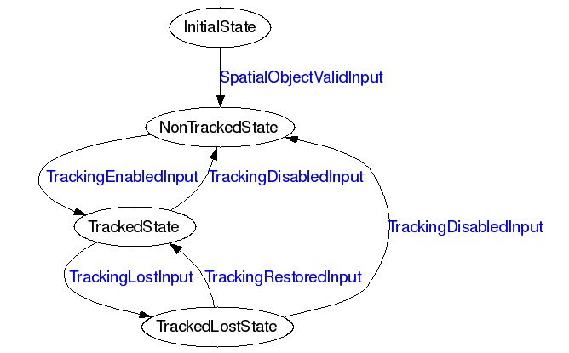

Figure 3. State Machine for an IGSTK Spatial Object.
Component-based architectures are naturally described in terms of state machines. Unfortunately, a lack of formality in traditional programming leads to under-defined state machines, where states and transitions are poorly defined. Such relaxed programming practices produce programs that behave erratically and unpredictably. These are exactly the kind of programs that are unacceptable in a critical application such as image-guided surgery. The need for reliability and robustness in IGSTK lead the development team to select the state machine model in the very early stages of the project. State machines ensure a program is always in a valid condition and that all possible behaviors are studied in advance by the developer in order to guarantee repeatable and deterministic behavior.

The application of state machines in IGSTK design provides:
- Safety and Reliability: A state machine ensures component behavior is deterministic and that all classes will be in a known and error-free state at any given moment.
- Cleaner design: Since developers must anticipate all possible inputs, states and transitions, the state machine encourages and enforces a cleaner and more robust design, free of untested assumptions. Furthermore, the correct implementation of the design can be exhaustively tested at run time and compared to the intended design.
- API simplicity: A focused, clearly expressed API is a must for supporting robustness and reliability. In the context of surgical guidance, we suggest flexibility and abundance of features are undesirable, because brings more opportunities for thing to go wrong during the surgical intervention.
- A consistent integration pattern: IGSTK’s value as it matures will undoubtedly be tied to the incorporation of additional functionality at the component level. This functionality will often take the form of reusable code from existing toolkits. State machines provide a clean consistent pattern for integrating this functionality while adhering to the safety-first principles necessitated by the application domain.
- Quality Control: State machines facilitate code coverage in the sense of lines of code tested as well as path coverage on a per component basis. Using code that is not based on state machines may result in applications that exhibit unpredictable and unreliable behavior. At run time, they can easily enter into any number of untold states that were never explored by the developer, possibly leading to error conditions that may or may not become visible to the users of the application.

The safety emphasis in IGSTK gears toward explicit knowledge of component state and whether a given behavior may be executed while in that state. Hence our application is a combination of traditional concepts in reliability (being in a known state) and the State Pattern [XXX Go4 ref.] (for managing availability of behavior dynamically). This is somewhat unique as most modern applications employing state machines focus almost exclusively on concurrent behaviors, such as those common in real-time embedded systems.

IGSTK Components
Component-based computing is a popular and prevalent model in modern computing architectures, yet its use in IGSTK was not a given. A component-based architecture provides for clean boundaries between subsystems within IGSTK. Components encapsulated behind these boundaries allow IGSTK to manage the complexity required in a safety-critical domain. Specifically, the ability to componentize the architecture provides the following benefits:

- Interaction patterns between components are easily visualized. Figure XXX shows the layering of IGSTK components and the patterns of interactions between them.
- Rigid component boundaries with well-understood interaction patterns allow for rigorous testing, creating “safe zones” at the component level.
- The framework is extensible in a structured way. Specialized implementations of behaviors are mapped to concrete realizations of base interfaces. Together with the State Machine, this ensures that component behavior is, in a sense, bounded. The component structure and state machine pattern also allow for extensibility to more complex deployment environments, including real-time and concurrent platforms.
- Component implementations that are based on reusable code are integrated into IGSTK in a safe manner. For example, IGSTK extends facilities provided by ITK and VTK, but does so in a restricted, predictable way, preventing unsafe introduction of external capabilities into IGSTK.
- From a development process perspective, fewer team members need to be concerned about component interactions, but instead focus concerns on a development area of specialty.

IGSTK’s layered component architecture does not come without costs. A principal concern is possible performance penalties incurred via extra method invocations required for wrapped functionality, as well as overhead associated with dynamic binding in a polymorphic language such as C++. While performance is not an insignificant concern, safety is the overriding requirement. Furthermore, although performance is slightly degraded, the performance predictability of the framework actually increases. We believe the predictability gained is worth the price paid over pure performance. A second concern is the complexity incurred in managing decoupled components. The abstraction layers introduced by componentization obscure linear views of realized functionality. As with any object-oriented software system that relies on encapsulation, specialization, and loose coupling, it can be more difficult for developers to unwind component interactions to troubleshoot issues during development.

Space limitations prevent a detailed presentation of individual components. We instead summarize the important features of each component layer and then describe a typical interaction.

Spatial Objects
Spatial Objects are central to mapping objects in a surgical environment onto a rendered surgical scene. This layer ties together the rendering functionality in the Viewer and Representation layers on the left of Figure XXX tracking functionality on the right.

An IGSTK Spatial Object can be attached to a Tracker object. A Spatial Object’s state machine enforces one Spatial Object is associated to only one Tracker, and that once it has been associated, it is no longer possible to change the position of the object programmatically. This again, ensures safety-by-design. IGSTK Spatial Objects are classes that encapsulate ITK Spatial Objects [XXX] inside a restricted API subject to the control of a state machine. In this way we obtain all the functionality without the risk associated with exposing all the flexibility of the ITK classes.

Tracker
A tracking device has the capability to provide position, orientation, and other relevant information pertaining to tracking tools. Normally each tracking device comes with a description of tracking tools it can track. A tracking tool is used for tracking by a tracking device as per the specification of the tracking device. The IGTSK Tracker component provides an object-oriented representation of tracking devices and tracking tools.

The internals of the Tracker require a separate thread to communicate with tracking hardware at an acceptable frequency. The Tracker component manages this communication and updates internal state at this frequency rate. Corresponding Spatial Objects then pull information from the Tracker at desired rendering frequencies.

Spatial Object Representation
XXX

Viewers
Viewers present renderings of surgical scenes to the clinician. These are critical since they are in many cases the main source of information presented to the clinician, especially in cases of minimally invasive surgery such as endovascular intervention and laproscopy. Viewers are built using VTK and FLTK classes that combined are encapsulated into a restrictive API and subject to the control of a state machine. Viewers limit the number of ways in which a user can interact with the scene. These interactions are defined considering that a surgeon may only have access to a touch screen in the surgery room, devoid of a keyboard or a mouse. In other contexts, an assistant may be manipulating the software under the verbal instructions given by the surgeon.

As shown in Figure XXX, the end user interacts with Viewers presented in an application interface. Viewers aggregate Spatial Object Representations, which in turn derive their rendering information from the Spatial Objects. Spatial Objects query Trackers to determine current position and orientation. To synchronize scene generation and provide an acceptable rendering frequency, IGSTK uses a PulseGenerator object to generate “ticks”, and a real-time clock mechanism to check timing intervals for validity of scene information. The current IGSTK implementation is single-threaded across component boundaries (there is a separate thread for the tracking device) and runs on common operating platforms such as Linux and Windows. Extending IGSTK for multithreading and real-time operating system services is a major emphasis for continued work on the framework.
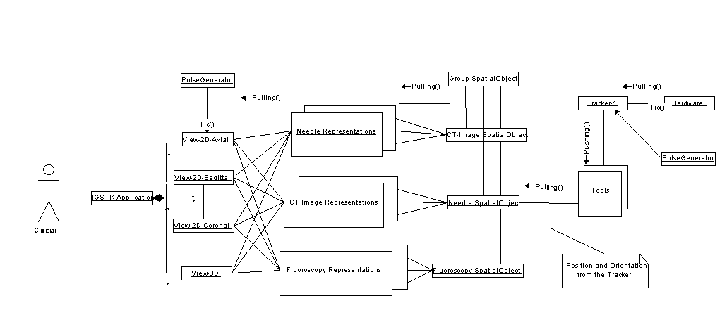
IGSTK Application Viewers Spatial Object Spatial Objects Tracker
Representations

Figure 4. IGSTK Component Architecture

Component Interaction and State Machines
Using Figure XXX as a reference, component interactions in IGSTK are such that components on the left of the figure request information or services from components on their right; components on the right move information to the left via events. A lightweight event model, an implementation of the Observer pattern [XXX], ensures information passed right-to-left is moderated at each layer by a state machine. Error-prone if/else conditions on return values are avoided. Instead, events are processed via a translation step to a state machine input. Again, in keeping with the principle of safety-by-design, the interaction in both directions happens under the purview of state machines. To understand why this is important, consider the rudimentary example diagrammed in Figure XXX:

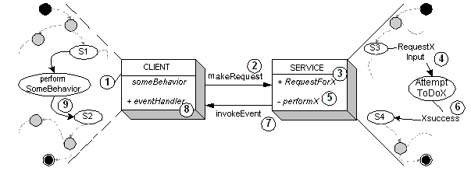

Figure 5. Sample State Machine managed interaction between components

In this example we term the component requesting service the CLIENT and the called component SERVICE. The relevant part of each component’s private state machine is shown next to the component. The interaction sequence is indicated by numbered circles. Initially, CLIENT is performing some behavior while in some well-known state of its state machine. CLIENT then makes a request for service (2) via a public method invocation on SERVICE. SERVICE accepts the request (3), and translates it to an input to its state machine (4). Based on the transition, a private method invocation on component SERVICE may also occur (5) representing the execution of the desired computation. Upon successful completion of the computation (6), SERVICE generates an event (7) containing the requested information and dispatches the event to CLIENT (8). CLIENT translates the event into an input on its state machine (9), thereby avoiding error-prone conditional logic on return values.

While this sequence may at first seem awkward to the conventional programmer compared to simply calling a method and checking its return value, it has several salient features that robustly enforce safety. When a component makes a request, it first transitions to a state indicating it is busy processing. By not performing a computation as an action associated with a transition, the state machine avoids situations where a component is “between” known states. This effectively makes IGSTK state machines Moore machines [XXX]. Second, IGSTK state machines use fully populated state transition tables, meaning no matter what input is given, a state machine will take a known and verified transition. Third, public request methods delegating to private behaviors mitigated by a component’s state machine protects the execution of the behavior. In other words, the behavior only gets executed when it is certain it is safe to do so. Finally, returning information via events that are translated to state machine inputs avoids error-prone conditional logic. The logic is embedded in a component’s state machine, and can be visualized and verified explicitly.

IGSTK Software Process
Open source is an increasingly popular model for software development and delivery. Many open source projects rely on skilled development teams whose members are distributed throughout the world. Often, these teams use Agile methods to facilitate an evolutionary style of development. IGSTK deals with unique complexities deriving from the nature of the requirements, the makeup of the team, the dependence on pre-existing software packages, and the need for high quality standards for surgical applications. We discuss these complexities in this section and suggest requirements techniques and quality management best practices that augment typical Agile methods to provide a robust process.

IGSTK Best Practices
IGSTK is a framework for supporting surgical applications, not a surgical system itself. Therefore it is not meaningful to describe correctness in terms of traditional measures such as rates of failure or repair (MTTF and MTTR). This is not to say that for a system including IGSTK these metrics have no value; it means such measures cannot be applied directly to the framework itself. IGSTK provides component-level wrappers interfacing devices (trackers and tools), users (clinicians), and image data (spatial representations and viewers). IGSTK itself has no control over the failure rate of, say, a particular tracking device instantiated in a given surgical environment. What IGSTK can control is how faults are handled by component wrappers, and whether these propagate into system failures. IGSTK relies on the state machine architecture to ensure that the software is always reliable, even if the physical environment is not.

IGSTK Quality Management processes focus on the correctness of the software and its ease of use. Correctness to us means the software fulfills all of, and only, the requirements in an error-free manner. This includes all nonfunctional requirements, in particular the overarching safety requirements for the framework. This definition of correctness includes completeness, intentionally sounding like a traditional definition of Verification and Validation (V&V). However IGSTK is Agile-oriented, so adopting a heavy process supporting correctness is not an option. Instead, IGSTK supports correctness via a collection of best practices weaved into a lightweight process framework to achieve the necessary level of quality. Ease of use means the correct utilization of the framework for application development in the surgical domain. This includes consistent APIs, patterns of interaction, coding style, documentation, and error-handling in a surgical environment.

We present our approach to quality as a set of overriding principles, or Best Practices:

- Recognize that people are the most important mechanism available for ensuring high quality software. The IGSTK team is comprised of developers with a high degree of training and experience with the application domain, supporting software, and tools. Their collective judgment is weighted over a high-level process mandate.
- Facilitate constant communication. To prevent over-isolation of a distributed team working on decoupled components, IGSTK facilitates constant communication. IGSTK members participate in a weekly teleconference and meet in person twice per year. IGSTK employs a mailing list and a Wiki for online collaboration.
- Produce iterative releases. IGSTK’s external release cycle includes twice-yearly releases. Internally, six months was considered too long a horizon to manage development, so releases are broken down into approximately two month “sprints” called iterations. At the end of an iteration development stops, code reviews and other quality reviews are performed, and code is considered stable is moved to the main code repository.
- Manage source code from a quality perspective. IGSTK applies different configuration management policies for managing code that satisfies different quality criteria. Separate codelines with separate policies allows developers to collaborate on code that may not yet meet stringent quality criteria. Exploiting configuration management approaches early in development helps document and track project quality progress.
- Focus on 100% code and path coverage at the component level. Unit tests are required to ensure 100% code coverage across all platforms. We are also developing a customized visualization and validation tool for IGSTK state machines, to ensure all paths within all state machines are executed at least once. Additionally, dynamic analysis tools ensure there are no memory leaks or access violations.
- Emphasize continuous builds and testing. IGSTK uses the open source DART tool (http://public.kitware.com/Dart/HTML/Index.shtml) to produce a nightly dashboard of build and unit test results across all supported platforms.
- Support the process with robust tools. Best Practice #5 describes the use of the DART tool for continuous testing. IGSTK also employs an open source cross-platform build solution called CMake (http://www.cmake.org/) and an open source documentation system called Doxygen (http://www.stack.nl/~dimitri/doxygen/). These tools are augmented with defined best practices for coding and documentation posted on the Wiki.
- Manage requirements iteratively in lockstep with code management. As requirements evolve and the code matures, it is necessary to adopt flexible yet defined processes for managing requirements. Requirements management is a complex process for a project such as IGSTK, and thus is discussed in detail in the next section.
- Focus on meeting exactly the current set of requirements. Traceability implies heavy process structures – large documents and invasive tools. Traceability is needed in safety-critical domains, in particular surgical applications needing FDA approval. IGSTK applies continuous requirements review (practice #6), lightweight tools (practice #7), and codeline policies (practice #4) to this problem.
- Evolve the process. Through constant communication, IGSTK members recognize when the complexities they face can be approached within the current process framework, when “tweaks” are required, or when entirely new practices should be adopted.

These Best Practices encompass the lightweight approach to robust software development in IGSTK. We do not equate “lightweight” with process “ignorance”; we readily recognize that a collection of good practices applied without structure will not lead to software quality. These Best Practices include process structures – namely people, managed requirements, continuous testing, and iterative development. “Lightweight” also does not mean “optional” process execution; IGSTK developers are not free to simply ignore Best Practices when convenient.

Lightweight Requirements Process
Significant expertise is needed to develop effective image-guided surgical applications. Development processes require a close connection between subject matter experts (SMEs) and software engineers. Waterfall and spiral development approaches tend to incorporate “top-down” processes that assume that complete requirements can be defined early in development. In this domain, we discovered that development processes must tightly integrate iterative involvement of medical professionals and SMEs. As such, agile development approaches are more inline with this domain. Approaches to requirements engineering and management are not well-defined within traditional agile development venues. In our work, we introduce a customized extension to standard agile development techniques through the introduction of an agile requirements management method.

Three Levels of Requirements Definition
Requirements define system constraints with an emphasis on the functionality that affects the end users. Since IGSTK is a component-based toolkit, there are three types of end users, software developers who use the components to compose new surgical applications, clinicians who use IGSTK applications, and software engineers that contribute components to the IGSTK framework. In all cases, requirements must meet the rigor necessary to assure the reliability of target applications.
IGSTK requirements are classified into three areas that represent the three different end users of the system. These three types of requirements, shown in Figure 1, are architecture requirements, style guidelines requirements, and application requirements, respectively.

Figure 1. Classification of Requirements in IGSTK.

Architecture requirements define how new systems should be composed from IGSTK components. Style guidelines include constraints on engineers who develop new software for IGSTK. Application requirements define how the target system will execute with respect to its use in the surgical environment. These classifications were derived from the authors’ earlier work defining a product line development process called Component-Based Product Line Analysis and Development (C-PLAD) [REF]. Interestingly, the concept of composing components to built higher-level applications is equally true when defining application requirements as they can be extended from requirements created at the component-level.

Agile Requirements Management Process
The process for requirements management is significantly integrated with code management. IGSTK development is not a purely agile process, but development requirements do percolate from the “bottom-up”. Developers introduce new requirements for further capabilities as components are developed. The IGSTK project employs a new collaborative process for reviewing, implementing, validating, and archiving these requirements, integrated with application development. This process is illustrated as a UML state diagram in Figure 2.

Figure 2. The Requirements Management Process as a UML state diagram.

Once a developer identifies new potential requirements (Conceptualized box in Figure 1), s/he posts a text description on the collaborative Wiki (Defined). At the same time, the initial code that fulfills the requirements is entered into a sandbox repository. The requirement then undergoes an iterative review process where team members review, discuss, and potentially modify the requirement. Based on the team’s decision, requirements are rejected or accepted. IGSTK uses an open source bug tracker (PHP BugTracker) to store requirements. This approach is particularly effective as defect reports and resulting actions are also stored in the bug tracker. The accepted requirements are entered into the bug tracker and marked as “open.” Once the supporting software is implemented and its functionality is confirmed, the requirement is marked as ‘verified.” As the nightly builds takes place, all verified requirements are automatically archived and exported into Latex and PDF files via custom scripts.

Conceptualizing Requirements via Collaborative Modeling
A barrier to conceptualizing requirements is the disparity of knowledge between software engineers and clinicians. These two groups tend to speak in totally different terms. In IGSTK, the best way for software engineers to collaborate with clinicians is by visualizing application scenarios. A UML activity diagram of the IGSTK guidewire placement application is illustrated in Figure 3 as discussed in earlier sections
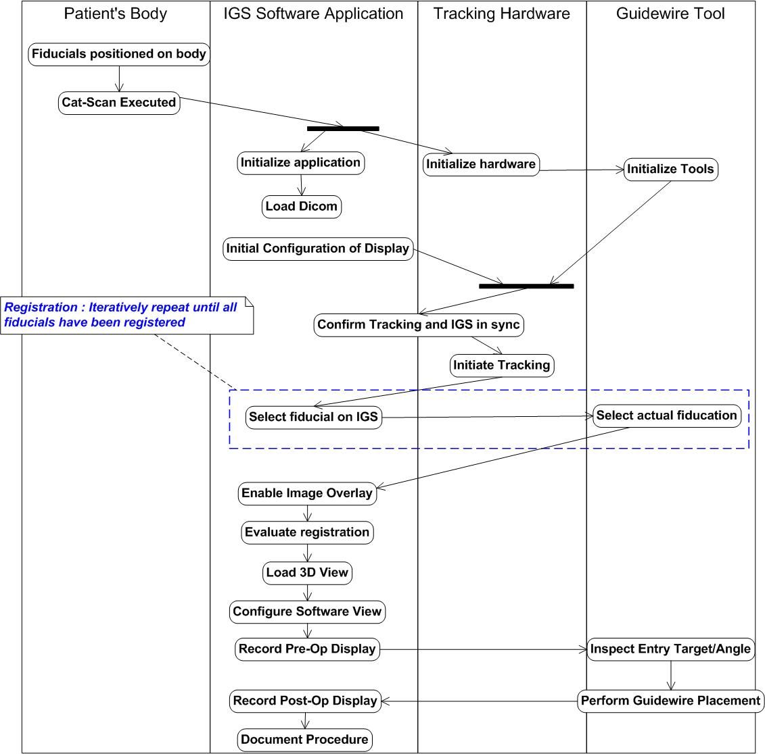
Figure 3. Activity Diagram Illustrating Guidewire Tracking Scenario.

An activity diagram is an effective collaboration medium for software engineers and clinicians. One can infer requirements from this activity diagram for all three requirements classifications defined earlier. We created several such diagrams during the initial application requirements gathering phase to facilitate the identification of the required functionality for IGSTK components.

Developing Requirements for Safety-Critical Software
Safety-critical applications demand that medical specialists understand concretely the functionality of the underlying software that they use, irrespective of the level (i.e. component-level or application-level). Defining requirements at each level in the presence of SMEs leverages agile development approaches in creating robust software. In addition, the visual modeling languages, as discussed in terms of activity diagrams, provide a vehicle for communication between software engineers and SMEs. Requirements engineering approaches within IGSTK concentrate on this tight interaction between medical specialists and the software engineers and close traceability between requirements and software. As a result of the well-defined processes and modeling approaches, there is a close traceability from software-to-requirements and requirements-to-specialists. The combination of these requirements engineering approaches and techniques assure that software is well-defined, managed, and understood by the users that will ultimately use them - a criteria for safety.

References

E. Watanabe, T. Watanabe, S. Manaka, Y. Mayanagi, and Y. Takakura, “Three dimensional digitizer neuronavigator: New equipment for computed tomography-guided stereotactic surgery,” Surg. Neurol., vol. 27, pp. 543–547, 1987.
Blake, M.B., Cleary, K., Kim, H.S., Ranjan, S.R., Gary, K., Jomier, J, Aylward, S., and Ibanez, L., " Component-Based Design and Development for Robust Medical Applications”, High Confidence Medical Device Software and Systems (HCMDSS) Workshop, Phialdelphia, PA, June 2005
Blake, M.B., Cleary, K., Ibanez, L., Ranjan, S. and Gary, K. " Use Case-Driven Component Specification: A Medical Applications Perspective to Product Line Development", Proceedings of the ACM Symposium on Applied Computing (SAC'05), Software Engineering Track, Sante Fe, New Mexico, March 2005

Also known as computer-aided surgery in the field.
DICOM stands for Digital Imaging and Communications in Medicine and has become the standard medical image file format 5. DICOM reference guide. Health Devices, 2001. 30(1-2): p. 5-30.. All major medical vendors of CT and MRI scanners provide a DICOM capability.

