IGSTK: Image-Guided Surgical ToolKit
An Open Source platform for Facilitating Image-Guided Surgical Application Development

Kevin Cleary
1 Dec 2005

Motivation
The Image-Guided Software Toolkit (IGSTK: pronounced IGstick) is an open source project aimed at developing robust software for patient-critical medical applications. Image-guided surgery involves the use of pre-operative medical images to provide image overlay and instrument guidance during procedures (Galloway 2001). Image-guided systems have been commercially available for almost ten years now, but developing new image-guided systems is an active field of research in the medical imaging community. Since these systems are intended to be used for patient care in a hospital setting, the robustness of the software is paramount. The majority of the effort in developing a new image-guided system is debugging and validating the software for implementing the algorithms, controlling the system, and displaying the results. The process we have evolved in creating this toolkit allows a distributed group of developers to collaborate with a focus on testing and quality control.

These considerations led us to form a multidisciplinary team of software engineers, medical imaging scientists, and clinical personnel to develop the image-guided surgery toolkit IGSTK. Requirements were developed through interviews with Interventional Radiologists who specialize in image-guided procedures. Three example applications were selected to drive the requirements process. The toolkit contains the basic software components of an image-guided system along with the example applications and a framework for application development. Using this toolkit and our software process we believe that it is possible to create robust software in an open source project that helps address FDA requirements and that can be used by researchers in academia and commercial companies.

Image-Guided Surgery

Background
Image-guided surgery is a rapidly developing field, since these procedures typically mean substantially less trauma for the patient. Image guidance was originally developed for neurosurgical applications as navigation in the brain requires great precision (Bucholz 1998). This technology allows the physician to use pre-operative computed tomography (CT) or magnetic resonance imaging (MRI) scans to guide minimally invasive procedures. Image guidance was then extended to spinal and orthopedic applications, such as pedicle screw placement (Foley and Smith 1996). Commercial image-guided surgery systems are now available for brain, spine, and ENT applications.
The basic concept of image-guided surgery is to provide the physician with a real-time update of the anatomy located in the region of a surgical instrument. This capability is provided by tracking the location of the instrument and the patient using devices known as trackers. Tracking than allows the display of the instrument location on a pre-operative medical image showing the anatomy of interest. This display can help guide the physician to the precise anatomical target and also provides the physician with a type of “x-ray vision” in that the physician can see what lies beneath a surgical instrument before starting the procedure.

A typical image-guided system is a complex merger of three major components: 1) a control computer; 2) software for image processing, control, and the user interface; and 3) a tracker for localizing instruments and the patient in three-dimensional space. Figure 1 shows a typical commercial computer-aided surgery system, the Stealthstation Treon™ from Medtronic Sofamor Danek. On the left hand side is the optical localizer, and on the right hand side is the control computer and display.

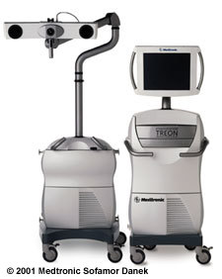
Figure 1: Typical image-guided surgery system
(courtesy of Medtronic Surgical Navigation Technologies)

The following is a typical sequence of steps in using an image-guided surgery system:
- A pre-operative CT or MRI scan is obtained – fiducials may be placed on the anatomy before this scan for later use in registration during the procedure.
- The CT or MRI images are imported into the computer – DICOM is the most common format used, although many vendors support proprietary formats as well.
- A “reference target” is attached to the anatomy to compensate for any inadvertent motion of the camera or patient.
- Registration is the next step – this procedure maps the image data set to physical locations on the patient’s anatomy.
- The system can now track surgical instruments, including probes or pointers, and display the anatomy beneath these instruments. A typical four quadrant view (axial, saggital, coronal, and 3D) is shown in Figure 2.
- Multiplanar reconstructions (i.e. oblique reformats) can also be provided at any angle to help carry out the procedure.

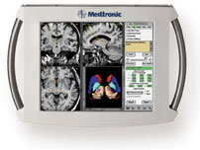
Figure 2: Typical four quadrant display (axial, saggital, coronal, and 3D)
(courtesy of Medtronic Surgical Navigation Technologies)

Need for Robust Software
The critical component of this system which consumes the great majority of the development effort when creating a new image-guided system is the software. The software must integrate information from the tracking system, correlate this information with the patient location, and display real-time updates of the underlying anatomy. The components are very tightly coupled and can be difficult to debug and validate using functional programming style.

Image-guided and minimally invasive techniques are continuing to grow in popularity and the international research community is rapidly expanding as well. However, because there is no readily available open-source software for image-guided surgery, many research groups are forced to develop their own software at a substantial cost both in time and effort. The main contribution of this project to the research community is the development of a high quality software toolkit (IGSTK) suitable for use in new image-guided surgery applications. Given that the IGSTK software is intended to be used in life-critical applications, it must be carefully designed and managed to ensure ease of use, robustness, and stability.

Example Applications from Toolkit

{note that here I just pasted the text from the Phase II proposal – obviously this will need to be greatly edited to maybe just one page and I will do so after I discuss with Kevin Gary and others}

Task 1: Demonstration Applications
Once the toolkit has been implemented and tested in Aim 2, the next step will be to develop three demonstration applications. Each of the three collaborating organizations (Kitware, Georgetown, and UNC) will be primarily responsible for one of these applications. The goal of this aim is to show the usefulness of the toolkit in developing clinically related applications as well as determining if there are any shortcomings in the toolkit that need to be rectified. These applications are intended to test the suitability of the IGSTK toolkit for implementing real clinical applications. These applications are not the final goal of this project and parts of these applications are being developed under independent funding so we are leveraging that effort here. The applications are:

- Application 1: Guidewire tracking (Georgetown)
- Application 2: Needle segmentation and tracking (Kitware)
- Application 3: Liver biopsy (UNC)

Application 1: Guidewire Tracking (Georgetown)
The goal of this application is to assess the feasibility of device navigation with electromagnetic tracking through a phantom study. We will provide an image overlay of an electromagnetically tracked guidewire as it is moved through the vasculature. The user interface will be similar to the example application shown in Section C.3.1.4, but we will also provide a magnified “scout or scanogram” view of the phantom to show the general position of the guidewire in the phantom, along with an axial CT scan of the phantom corresponding to the tip of the guidewire. This would be useful in clinical applications such as aneurysm clipping, stent graft deployment and positioning, and catheter navigation for chemoembolization or transhepatic portal systemic shunt creation, as it would provide the physician with a more detailed view of the anatomy.
The clinical partner for this application will be Brad Wood, MD, an interventional radiologist at the NIH Clinical Center. Dr. Wood has collaborated with the principal investigator Dr. Cleary on a number of other projects and an abstract on the guidewire tracking concept has been accepted at the 2004 Society of Interventional Radiology annual meeting. This application will be validated on the vascular phantom developed by Dr. Wood in conjunction with Georgetown and shown in Figure 3. The phantom includes several vessels that can accept the magnetically tracked guidewire. The guidewires will be supplied by Neil Glossop, PhD, of Traxtal Technologies as part of another project (see letter of support in the appendix). A picture of a prototype guidewire is shown in Figure 4.
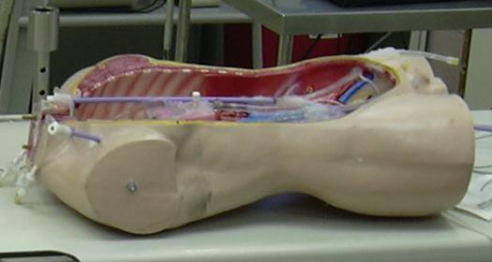 | 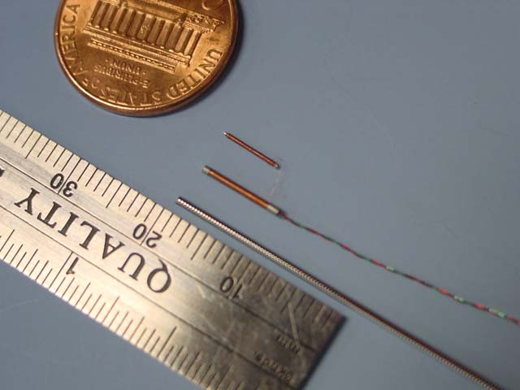
Figure 3: Vascular phantom for guidewire test | Figure 4: Electromagnetically tracked guidewire  (courtesy of Traxtal Technologies)

Once the software has been developed, the utility of the system will be evaluated as follows. This test will be done in the interventional suite at Georgetown. The sequence of steps is:

- Fiducials that are visible in CT images are placed on the phantom. Internal fiducials along the vascular tree (such as major bifurcations and identifiable branches or plaques) will also be identified and used in a separate arm of the phantom study.
- The phantom is CT scanned.
- The images are loaded on the workstation and the fiducials are then located in CT space by asking the interventionalist to select them using the mouse.
- The fiducials are located in electromagnetic space by enabling the electromagnetic tracking system and touching each fiducials with the magnetically tracked guidewire.
- The information from steps 3 and 4 is used to determine the transformation between CT space and electromagnetic space using the method of Arun (Arun, Huang et al. 1987).
- The guidewire can then be tracked on a scout image to show the general position of the guidewire within the phantom as well as showing an axial CT image at the tip of the guidewire.
- With the phantom in the angiography environment, the guidewire will be placed in a catheter in the vessels in the phantom, and the utility and error of the system will be evaluated by two interventional radiologists (Dr. Wood and Dr. Levy). Navigation will be performed using angiography with dual display of tracking position in CT space (axial and multiplanar reconstruction images based upon position and orientation of guidewire).

Application 2: Needle Segmentation and Tracking (Kitware)
Needle detection and tracking is a task commonly found in image-guided surgery. A set of IGSTK components will be implemented for providing the functionalities of needle segmentation and tracking. These components will be exercised in an application used for guiding the positioning of a surgical needle based on the information provided by an intra-operative fluoroscopy system. The needle tracking application considered here has been already developed at the Georgetown ISIS center under independent funding with the aim of guiding a robotically assisted needle insertion system. This application will be reworked in order to factorize the software elements that will constitute needle tracking component. The application will be adapted in order to use the new component and verify that it performs as intended.
Figure 5 illustrates the clinical environment in which this application is currently being tested. A fluoroscopy C-Arm is used for gathering intra-operative images of the patient. A robot is used for positioning the tip of the surgical needle at the entry point in the patient’s skin and for orienting the needle in order to aim at a target in the internal anatomy. In this procedure, the final insertion of the needle is performed by the clinician by using a joystick to control the robot. Figure 6 shows the segmentation of the surgical needle overlaid into the fluoroscopic image. The blue points indicate the pixels segmented as members of the needle. The cross marks are references to the region of interest used during the segmentation and to the position of the needle’s head, tip and middle points respectively.
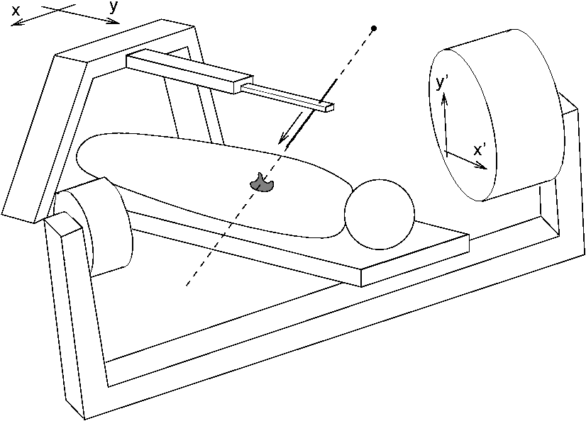 | 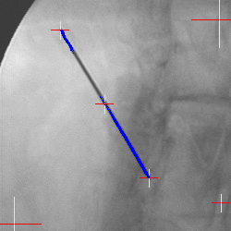 | 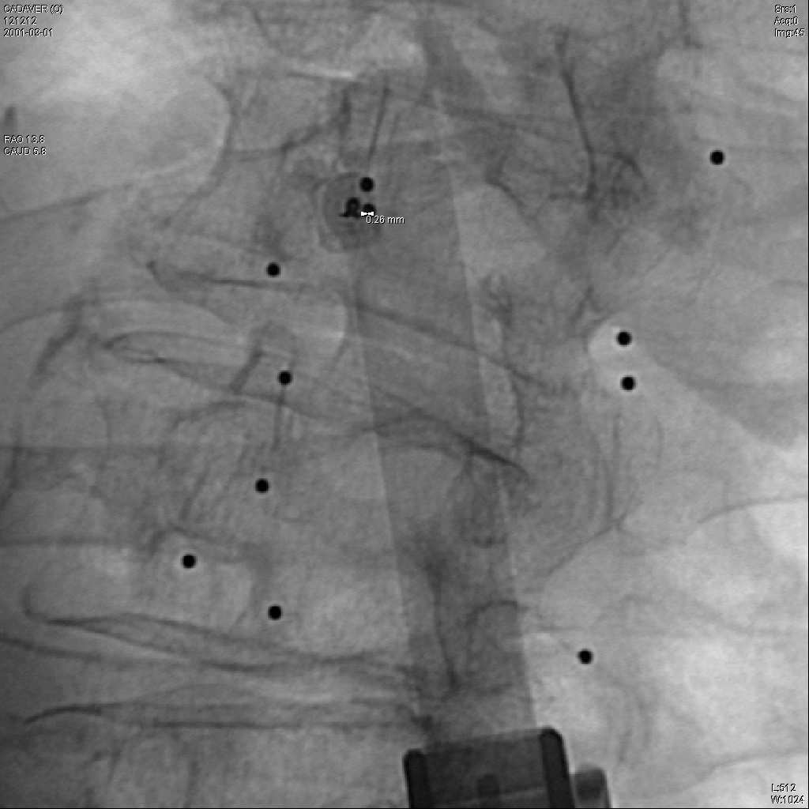
Figure 5: Clinical setup for robotically assisted needle insertion. | Figure 6: Surgical needle segmentation from a fluoroscopic image. | Figure 7: Fluoroscopic image of needle aligned with the direction of insertion.

In order to calibrate the position of the robot with respect to the image-plane of the fluoroscope, we displace the robot arm along known directions and by known distances in a 2D plane parallel to the operating table. These displacements, when projected onto the image plane of the fluoroscope result in a different set of directions and distances as seen on the fluoroscopic image. By measuring the observed displacements in the image plane it is possible to estimate a two dimensional affine transform mapping the robot coordinate system into the fluoroscopic image coordinate system. This mapping disregards the perspective effect due to the natural divergence of X-rays emanated from the fluoroscope’s source. This approximation is justified due to the small region in space under which the robot is displaced, typically a cube with side length of 50mm. Once the 2D affine transformation between the robot and image planes has been estimated, it is then used for computing the movement required in the robot arm in order to reach a target that has been identified in the fluoroscopic image. Because of the lack of depth information in a single projection of the fluoroscopic image, the needle tip is simply placed on the line of sight between the anatomical target and the fluoroscope. Having the needle’s tip on the line of sight, the application proceeds to orient the needle until it is parallel to the line of sight. The needle is considered to be aligned when the size of its projection on the fluoroscopic image is minimized. This geometrical configuration is shown in Figure 7. At that moment the needle is ready for insertion in the patient’s anatomy. The C-Arm is then rotated to a position where the line of sight is almost orthogonal to the direction of insertion, and the control is left to the clinician for manually control the insertion process using the robot’s joystick. This application has been validated in a preliminary cadaver study were BBs (small metal balls) have been inserted to serve as verifiable targets.
Figure 8 illustrates the IGSTK software components that can be integrated in this application in order to provide high level functionalities. It shows a video input component used for acquiring the fluoroscopic image, a needle segmentation component for detecting the needle on the image, and a 3D/2D registration component intended to overlay geometrical models of the anatomy in a virtual view of the fluoroscopic image.
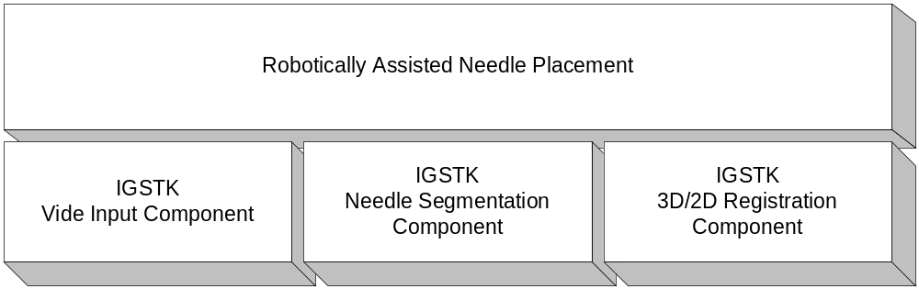
Figure 8: IGSTK Components used to modularize the implementation
of the robotically assisted needle placement application.

Application 3: 3D Ultrasound Augmentation for Percutaneous Liver Lesion Biopsy Guidance (UNC)
We propose to test the extensibility of IGSTK by developing and evaluating a 3D image-based registration module that aligns intra-operative 3D ultrasound data with pre-operative MR and CT data. Using this module we will define an IGSTK system that updates the position of internal organs in the pre-operative data using intra-operative 3D ultrasound data. We call this system 3D Ultrasound Augmentation (3DUA). This system tracks internal organ movement without requiring intravenous access and is generally useful when organ movement cannot be well predicted or tracked using external markers.
To evaluate our system, we will test the hypothesis that by using 3DUA, a needle can be guided to within 5 mm (maximum error) of a point seen only on pre-operative data. We will conduct these tests using a turkey breast as a phantom, MR as the pre-operative imaging modality, our Voluson 530D 3D ultrasound system for intra-operative data, and a core biopsy needle.
The 3DUA system builds upon the AURORA modules to track the ultrasound probe and patient so as to initialize the registration of the intra-operative 3D ultrasound data and the pre-operative CT/MR data. The image-based registration module then refines that registration so as to account for the intra-operative displacement of a designated organ (the designated organ defines a region of interest for the CT/MR-to-3D-ultrasound registration method). The tracked needle is then overlaid onto the re-registered CT/MR data. Figure 9 illustrates the fusion of a lesion seen on CT with vessels and data from an intra-operative 3D ultrasound scan – the fused view is oriented with respect to the position of the patient on the table. Figure 10 illustrates preliminary results from the registration metric: one slice of co-registered MR and 3D ultrasound data of a liver. This work builds upon the CADDLab’s (Radiology, UNC) vessel extraction (Aylward, Bullitt et al. 1996; Bullitt, Liu et al. 1999; Aylward and Bullitt 2002), ITK, and image registration (Aylward, Jomier et al. 2002; Aylward, Jomier et al. 2003) experience. Our particular expertise is the development of clinically useful software.
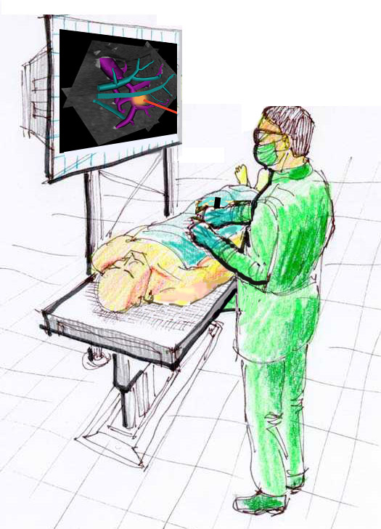 | 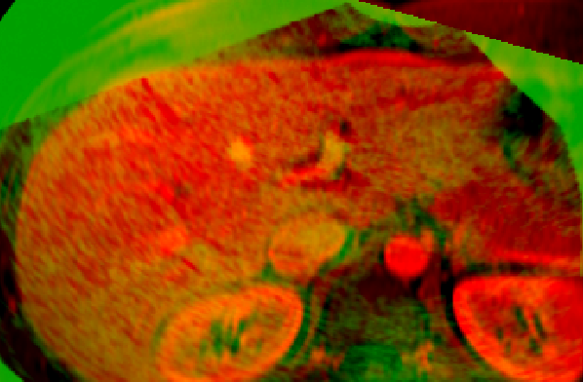
Figure 9: 3D ultrasound data is oriented as the patient is oriented on the table to simplify biopsy guidance | Figure 10: One slice of 3D US and MR liver data that has been registered using the proposed method

The software goal of this project is to develop an extensible image registration module for image-based intra-operative guidance. The software components of a registration module are the transform (e.g., rigid, affine, B-spline deformable), the interpolator (e.g., nearest-neighbor, linear), the optimizer (e.g., conjugate gradient descent, genetic algorithm), and the metric (e.g., mutual information, normalized correlation). The Insight Toolkit will provide the framework and implementations for these components. The specific registration module components to be used for the proposed work involve a novel registration metric that has been previously described (Aylward, Jomier et al. 2003) and shown to provide 2.3 mm (maximum error) accuracy in 2-3 seconds when aligning clinical MR with 3D ultrasound data of the liver (Aylward, Jomier et al. 2002) (Figure 10). The components and parameters used to generate those results will be wrapped for use in IGSTK and used in the following evaluation.
- We will insert a 1 cm round piece of turkey meat into a crevice of a turkey breast. The inserted piece of turkey will have been stained red and soaked in Gadolinium. Because of the Gadolinium, it will appear on MR. Because it is turkey meat, as is the rest of the phantom, it will not be well visualized on ultrasound (it might be possible to slightly detect its boundary, but since it is located in a pre-existing crevice, it will not be uniquely identifiable). If it is biopsied, the sample will be red.
- The turkey breast will be fixed to the bottom of a shallow tank of water to increase the operating volume so as to reflect distances common to percutaneous liver lesion access.
- The tank and turkey will be imaged using a 3T Siemens Allegra MR scanner. The Siemens 3D VIBE protocol will be used. The VIBE protocol is a 17-second post-contrast acquisition sequence that is typically used to image liver vasculature and tumors for surgical planning; it captures 0.6x0.6x2.5mm voxels that are interpolated using an ITK b-spline filter to produce isotropic 1.2x1.2x1.2mm voxels.
- We will use existing IGSTK modules to designate the center of the target turkey piece on the MR scan.
- We will use 3DUA to guide a biopsy needle to the target by registering 3D ultrasound images with the pre-operative MR and providing a fused view of those images to the user (Figure 10). The ultrasound scanner is a Medison Inc. Voluson 530D 3D scanner. The parabolic probe is held in-place for 7 seconds to acquire a 256x256x256 volume having 0.5x0.5x0.5mm isotropic voxels. Each recorded image is sent to a PC in the interventional suit using a DICOM push command. The PC uses the proposed image-based registration module of IGSTK to fuse and display the ultrasound and MR data.

This evaluation will be repeated for five different turkey breasts. For each breast, three different approaches will be used to acquire three different biopsy samples. The number of biopsy samples containing more than 50% red tissue will be reported as the number of times the system achieved 5 mm (maximum error) accuracy. Registration module and total acquisition-to-display speed will also be recorded.
The resulting image registration module truly increases the variety of interventions supported by IGSTK and demonstrates the extensibility of ITK. Specifically, the 3DUA system is independent of the 3D ultrasound machine used to acquire the data. In fact, the registration method is applicable to a wide variety of combinations of pre and intra-operative imaging modalities; it has been shown to operate for CT-CT, MR-MR, and ultrasound-ultrasound registration (Aylward, Jomier et al. 2003; Chillet, Jomier et al. 2003) in addition to MR-ultrasound registration (Aylward, Jomier et al. 2002). Additionally, with the incorporation of intra-operative 3D image-based registration, IGSTK now addresses the vast majority of clinical and research intra-operative tracking techniques: electromagnetic/optical fiducial tracking, fluoroscopic imaging, and interventional MR/CT/ultrasound imaging. Similarly, the components of registration (e.g., the use of a deformable transform and a normalized mutual information metric) are exposed to the programmer for easy modification and experimentation, thereby simplifying further research in each of those important areas.

(end of text)

Also known as computer-aided surgery in the field.
DICOM stands for Digital Imaging and Communications in Medicine and has become the standard medical image file format 5. DICOM reference guide. Health Devices, 2001. 30(1-2): p. 5-30.. All major medical vendors of CT and MRI scanners provide a DICOM capability.

