IGSTK: Image-Guided Surgical ToolKit
An Open Source platform for Facilitating Image-Guided Surgical Application Development

Kevin Gary, Mwaffaq Otoom (DCST, ASU)
Brian Blake (CS, Georgetown)
Kevin Cleary, Patrick Cheng (ISIS, Georgetown)
Rick Avila, Andinet Enquobahrie, Luis Ibanez, Will Schroeder (Kitware)
David Gobbi (Atamai)
Stephen Awlyard, Julien Jomier (UNC – dept.?)

Motivation
The Image-Guided Software Toolkit (IGSTK: pronounced IGstick) is an open source project aimed at developing robust software for patient-critical medical applications. Image-guided surgery involves the use of pre-operative medical images to provide image overlay and instrument guidance during procedures (Galloway 2001). Image-guided systems have been commercially available for almost ten years now, but developing new image-guided systems is an active field of research in the medical imaging community. Since these systems are intended to be used for patient care in a hospital setting, the robustness of the software is of primary importance; most of the effort in developing a new image-guided system is debugging and validating the software for implementing the algorithms, controlling the system, and displaying the results.

These considerations led us to form a multidisciplinary team of software engineers and medical imaging scientists to develop the image-guided software toolkit IGSTK. I’d emphasize multidisciplinary and team in this paragraph – not the components of the toolkit. Talk about software experts, interviews with radiologists, and applications and requirements driving the toolkit development.

A typical image-guided system is a complex merger of three major components: 1) a control computer; 2) software for image processing, control, and the user interface; and 3) a device called a tracker for localizing instrument and the patient in three-dimensional space. Each interoperates. Difficult to debug and validate using functional programming style…

The toolkit contains the basic software components and framework for application development and testing. Thoroughly tested…sample applications included…

Using our toolkit and our software process we believe that it is possible to create robust software in an open source project that helps address FDA requirements and that can be used by researchers in academia and commercial companies.

Outline needed: my vote for the ordering:
- first more on surgical guidance systems – this audient may be very unfamiliar with these – show a picture or two of a OR – give the broad components of an IGS system
- then requirements – this would be interesting to a large portion of the audience
- then state machines as the software design – appeals to a slightly smaller portion of the audience
- then component details
- then validation and debugging

Architecture
IGSTK supports safety-critical surgical applications; software errors may lead to catastrophic results. IGSTK minimizes risk of harm to the patient resulting from negligent or accidental misuse of the framework. This goal of safety-by-design is achieved by adherence to the following principles:

- Every component is based on a State Machine abstraction. The state of a component is explicit and always known, and precautions are taken for making sure the component is never set in an invalid state.
- IGSTK uses a component-based layered architecture style. Every component has a minimal set of features. Only features providing necessary functionality are implemented. Strongly-typed interfaces provide enforceable interaction contracts between components.

This section presents the IGSTK architecture by focusing on these two principles.

State Machine Pattern
State machines are a fundamental concept in computer programming. A state machine is defined by a set of states, a set of inputs, and a set of directed transitions between states. Transitions in a state machine change the current state of the state machine in response to some stimulus, or input. A behavior, or action, may execute at various junctures of a state machine, such as during a transition, on entry to a state, or on exit to a state. A common representation of design semantics for state machines based on Harel’s Statecharts [XXX] is given in the UML [XXX]. A full treatment of the formal semantics of state machines is beyond the scope of this paper. However, it is worth noting that the presence of formal semantics and a wide field of study on state machines influenced our decision to go with this trusted architectural pattern.

Component-based architectures are naturally described in terms of state machines. Unfortunately, a lack of formality in traditional programming leads to under-defined state machines, where states are poorly defined, and transitions between states are rarely defined explicitly. Such relaxed programming practices produce programs that behave erratically and unpredictably. Those are exactly the kind of programs that are unacceptable in a critical application such as image-guided surgery. The need for reliability and robustness in IGSTK lead the development team to select the state machine model in the very early stages of the project. State machines ensure a program is always in a valid condition and that all possible behaviors are studied in advance by the developer in order to guarantee repeatable and deterministic behavior.

A generic state machine class is available in the toolkit and provides the abstraction of the set of states, the set of inputs and the set of transitions. Each IGSTK component internally instantiates its own state machine and programs its full structure, ensuring compile-time safety of the initialization process. The state machine anticipates how components work when their methods are invoked in any order. Object-oriented components rarely behave correctly or at least without run-time failures when their methods are invoked in random order.

API simplicity is a must for supporting robustness and reliability. In the context of surgical guidance, we suggest flexibility and abundance of features are undesirable, because each one of them brings more opportunities for thing to go wrong during the surgical intervention. In this sense, state machines also serve as the fundamental integration pattern for IGSTK components. IGSTK component realizations (described in Section XXX) often leverage existing source code from other projects, such as ITK, VTK, FLTK, and Atamai Tracker code. The state machine forces the functionality of these packages to be incorporated in a restricted safe manner by reifying component state, transitions, behaviors, and the allowed relationships between them.

State machines facilitate test coverage in terms of the number of lines executed during testing and also in terms of the possible execution paths in the code. The IGSTK team is currently creating custom tool support for component-level state machines as part of the quality process. This is discussed more in Section XXX.

To summarize, the use of state machines in IGSTK design provides:
- Safety and Reliability: A state machine ensures component behavior is deterministic and that all classes will be in a known and error-free state at any given moment.
- Cleaner design: Since developers must anticipate all possible inputs, states and transitions, the state machine encourages and enforces a cleaner and more robust design, free of untested assumptions. Furthermore, the correct implementation of the design can be exhaustively tested at run time and compared to the intended design.
- A consistent integration pattern: IGSTK’s value as it matures will undoubtedly be tied to the incorporation of additional functionality at the component level. This functionality will often take the form of reusable code from existing toolkits. State machines provide a clean consistent pattern for integrating this functionality while adhering to the safety-first principles necessitated by the application domain.
- Quality Control: State machines facilitate code coverage in the sense of lines of code tested as well as path coverage on a per component basis. Using code that is not based on state machines may result in applications that exhibit unpredictable and unreliable behavior. At run time, they can easily enter into any number of untold states that were never explored by the developer, possibly leading to error conditions that may or may not become visible to the users of the application.

Applying state machines for reliable systems is not unique. However, the safety emphasis in IGSTK gears toward explicit knowledge of component state and whether a given behavior may be executed while in that state. Hence our application is a combination of traditional concepts in reliability (being in a known state) and the State Pattern [XXX Go4 ref.] (for managing availability of behavior dynamically). This is somewhat unique as most modern applications employing state machines focus almost exclusively on concurrent behaviors, such as those common in real-time embedded systems.

IGSTK Components
IGSTK employs a component-based architecture. While component-based computing is a popular and prevalent model in modern computing architectures, its use was not a given. A component-based architecture provides for clean boundaries between subsystems within IGSTK. Components encapsulated behind these boundaries allow IGSTK to manage the complexity required in a safety-critical domain. Specifically, the ability to componentize the architecture provides the following benefits:

- Interaction patterns between components are easily visualized. Figure XXX shows the layering of IGSTK components and the patterns of interactions between them.
- Rigid component boundaries with well-understood interaction patterns allow for rigorous testing, creating “safe zones” [XXX] at the component level.
- The framework is extensible in a structured way. Specialized implementations of behaviors are mapped to concrete realizations of base interfaces. Together with the State Machine, this ensures that component behavior is, in a sense, bounded. The component structure and state machine pattern also allow for extensibility to more complex deployment environments, including real-time and concurrent platforms.
- Component implementations that are based on reusable code are integrated into IGSTK in a safe manner. For example, IGSTK extends facilities provided by ITK and VTK, but does so in a restricted, predictable way, preventing unsafe introduction of external capabilities into IGSTK.
- From a development process perspective, fewer team members need to be concerned about component interactions, but instead focus concerns on a development area of specialty.

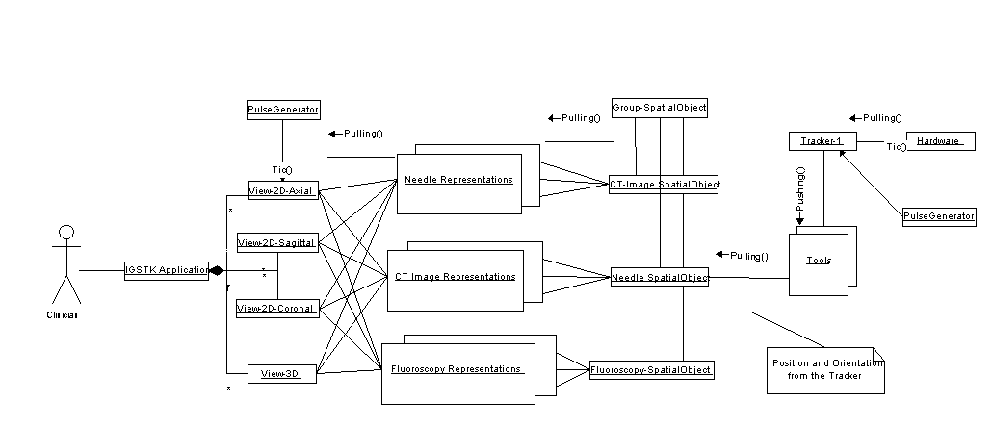
IGSTK Application Viewers Spatial Object Spatial Objects Tracker
Representations

Figure XXX. IGSTK Component Architecture

As shown in Figure XXX, the end user interacts with Viewers presented in an application interface. Viewers aggregate Spatial Object Representations, which in turn derive their rendering information from the Spatial Objects. Spatial Objects query Trackers to determine current position and orientation. To synchronize scene generation and provide an acceptable rendering frequency, IGSTK uses a PulseGenerator object to generate “ticks”, and a real-time clock mechanism to check timing intervals for validity of scene information. The current IGSTK implementation is single-threaded across component boundaries (there is a separate thread for the tracking device) and runs on common operating platforms such as Linux and Windows. Extending IGSTK for multithreading and real-time operating system services is a major emphasis for continued work on the framework.

IGSTK’s layered component architecture does not come without costs. A principal concern is possible performance penalties incurred via extra method invocations required for wrapped functionality, as well as overhead associated with dynamic binding in a polymorphic language such as C++. While performance is not an insignificant concern, safety is the overriding requirement. Furthermore, although performance is slightly degraded, the performance predictability of the framework actually increases. We believe the predictability gained is worth the price paid over pure performance. A second concern is the complexity incurred in managing decoupled components. The abstraction layers introduced by componentization obscure linear views of realized functionality. As with any object-oriented software system that relies on encapsulation, specialization, and loose coupling, it can be more difficult for developers to unwind component interactions to troubleshoot issues during development. It also becomes more difficult to determine code coverage during testing, as we discuss in Section XXX.

Space limitations prevent a detailed presentation of individual components. We instead summarize the important features of each component layer and then describe a typical interaction.

Spatial Objects
Spatial Objects are central to mapping objects in a surgical environment onto a rendered surgical scene. This layer ties together the rendering functionality in the Viewer and Representation layers on the left of Figure XXX tracking functionality on the right.

IGSTK Spatial Objects can be attached to a Tracker object. A Spatial Object’s state machine enforces one Spatial Object is associated to only one Tracker, and that once it has been associated, it is no longer possible to change the position of the object programmatically. This again, ensures safety-by-design. The IGSTK Spatial Objects are classes that encapsulate ITK Spatial Objects [XXX] inside a restricted API subject to the control of a state machine. In this way we obtain all the functionality without the risk associated with exposing all the flexibility of the ITK classes.

Tracker
A tracking device has the capability to provide position, orientation, and other relevant information pertaining to tracking tools. Normally each tracking device comes with a description of tracking tools it can track. A tracking tool is used for tracking by a tracking device as per the specification of the tracking device. The IGTSK Tracker component provides an object-oriented representation of tracking devices and tracking tools.

The Tracker component was adopted from a set of C++ tracker classes donated to the project by Atamai Inc. [1]. The code has been reorganized to fit the State Machine architecture and to connect seamlessly with the Spatial Object classes described above.
The internals of the Tracker require a separate thread to communicate with tracking hardware at an acceptable frequency. The Tracker component manages this communication and updates internal state at this frequency rate. Corresponding Spatial Objects then pull information from the Tracker at desired rendering frequencies.

Tracker component implementations are available for the AURORA and POLARIS tracking devices (Northern Digital Inc., Waterloo, Canada). The Tracker component does not communicate directly with these devices via the serial port, but instead communicates via a SerialCommunication object that acts as a proxy between the Tracker and the tracking device. The use of this communication proxy allows all platform-dependent serial port control code is contained within the communication object, while the Tracker code is fully platform independent. The communication proxy may also be replaced with a “simulator” that replays previously recorded serial data streams for testing or demo purposes.

Spatial Object Representation
XXX

Viewers
Viewers present renderings of surgical scenes to the clinician. These are critical since they are in many cases the main source of information presented to the clinician, especially in cases of minimally invasive surgery such as endovascular intervention and laproscopy. Viewers are built using VTK and FLTK classes that combined are encapsulated into a restrictive API and subject to the control of a state machine. Viewers limit the number of ways in which a user can interact with the scene. These interactions are defined considering that a surgeon may only have access to a touch screen in the surgery room, devoid of a keyboard or a mouse. In other contexts, an assistant may be manipulating the software under the verbal instructions given by the surgeon.

Viewer functionality is realized by a base View class with concrete subclasses for two dimensional and three dimensional views. Concrete classes are instantiated into objects providing a particular view perspective. For example, in the screenshot in Figure XXX, three two dimensional views are instantiated, one each for axial, sagittal, and coronal perspectives of the scene.

Component Interaction and State Machines
Using Figure XXX as a reference, component interactions in IGSTK are such that components on the left of the figure request information or services from components on their right; components on the right move information to the left via events. A lightweight event model, an implementation of the Observer pattern [XXX], ensures information passed right-to-left is moderated at each layer by a state machine. Error-prone if/else conditions on return values are avoided. Instead, events are processed via a translation step to a state machine input. Again, in keeping with the principle of safety-by-design, the interaction in both directions happens under the purview of state machines. To understand explicitly why this is important, consider the following rudimentary example diagrammed in Figure XXX:

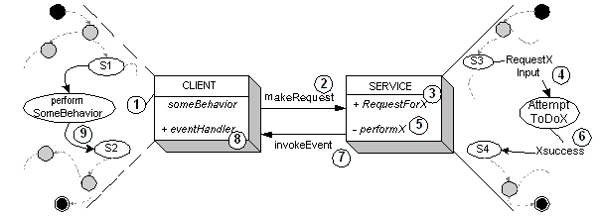

Figure XXX. Sample State Machine managed interaction between components

In this example we term the component requesting service the CLIENT and the called component SERVICE. The relevant part of each component’s private state machine is shown next to the component. The interaction sequence is indicated by numbered circles. Initially, CLIENT is performing some behavior while in some well-known state of its state machine. CLIENT then makes a request for service (2) via a public method invocation on SERVICE. SERVICE accepts the request (3), and translates it to an input to its state machine (4). Based on the transition, a private method invocation on component SERVICE may also occur (5) representing the execution of the desired computation. Upon successful completion of the computation (6), SERVICE generates an event (7) containing the requested information and dispatches the event to CLIENT (8). CLIENT translates the event into an input on its state machine (9), thereby avoiding error-prone conditional logic on return values.

While this sequence may at first seem awkward to the conventional programmer compared to simply calling a method and checking its return value, it has several salient features that robustly enforce safety. When a component makes a request, it first transitions to a state indicating it is busy processing. By not performing a computation as an action associated with a transition, the state machine avoids situations where a component is “between” known states. This effectively makes IGSTK state machines Moore machines [XXX]. Second, IGSTK state machines use fully populated state transition tables, meaning no matter what input is given, a state machine will take a known and verified transition. Third, public request methods delegating to private behaviors mitigated by a component’s state machine protects the execution of the behavior. In other words, the behavior only gets executed when it is certain it is safe to do so. Finally, returning information via events that are translated to state machine inputs avoids error-prone conditional logic. The logic is embedded in a component’s state machine, and can be visualized and verified explicitly.

Figure XXX shows a concrete example of a state machine for the IGSTK Tracker component.

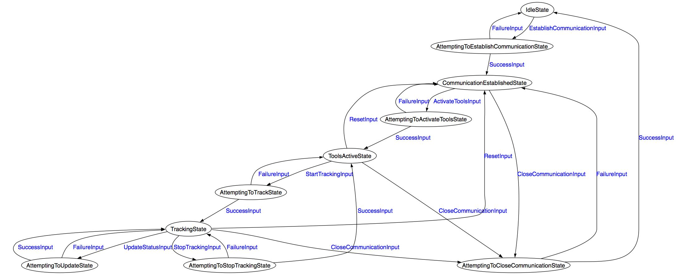

Figure XXX. IGSTK Tracker State Machine

The state machine here is a mirror of the actual states of the physical tracking device, ensuring that only commands that the device is ready to correctly respond to will be sent to the device. This safety is provided purely through the design of the Tracker’s state machine, without the need for if/else error checking throughout the code. The ultimate goal, as far as code safety is concerned, is for unexpected responses from the device to occur only in the unlikely event of a device malfunction.

IGSTK’s component-based architecture, with regulated interactions via state machines, provides a robust platform with the potential to satisfy demanding safety and correctness requirements. The architecture is the principal mechanism by which IGSTK portends to satisfy these requirements, however, it is not the only piece. In the next section we turn to another critical piece, the Agile methodology the IGSTK has adopted for developing the framework.

IGSTK Software Process
Need general motivation section here XXX

Lightweight Requirements Process
Significant expertise is needed to develop effective image-guided surgical applications. Development processes require a close connection between subject matter experts (SMEs) and software engineers. Waterfall and spiral development approaches tend to incorporate “top-down” processes that assume that complete requirements can be defined early in development. In this domain, we discovered that development processes must tightly integrate iterative involvement of medical professionals and SMEs. As such, agile development approaches are more inline with this domain. Approaches to requirements engineering and management are not well-defined within standard agile development venues. In our work, we introduce a customized extension to standard agile development techniques through the introduction of an agile requirements management method.

Three Levels of Requirements Definition
Requirements define system constraints with an emphasis on the functionality that affects the end users. Since IGSTK is a component-based toolkit, there are three types of end users, software developers who use the components to compose new surgical applications, clinicians who use IGSTK applications, and software engineers that contribute components to the IGSTK framework. In all cases, requirements must meet the rigor necessary to assure the reliability of target applications.
IGSTK requirements are classified into three areas that represent the three different end users of the system. These three types of requirements, shown in Figure 1, are architecture requirements, style guidelines requirements, and application requirements, respectively.

Figure 1. Classification of Requirements in IGSTK.

Architecture requirements define how new systems should be composed from IGSTK components. Style guidelines include constraints on engineers who develop new software for IGSTK. Application requirements define how the target system will execute with respect to its use in the surgical environment. These classifications were derived from the author’s earlier work defining a product line development process called Component-Based Product Line Analysis and Development (C-PLAD) [REF]. Interestingly, as applications are built from the underlying components, the application requirements extend the component-level requirements. The classification of requirements and their relationship to other types of requirements are illustrated in Figure 1.

Agile Requirements Management Process
The process for requirements management is significantly integrated with code management. IGSTK development is not a purely agile process, but development requirements do percolate from the “bottom-up”. Developers introduce new requirements for further capabilities as components are developed. The IGSTK project employs a new collaborative process for reviewing, implementing, validating, and archiving these requirements, integrated with application development. This process is illustrated as a UML state diagram in Figure 2.

Figure 2. The Requirements Management Process as a UML state diagram.

Once a developer identifies new potential requirements (Conceptualized box in Figure 1), the developer will post a text description (Defined) on the shared web site (Wiki). At the same time, the initial code that fulfills the requirements is entered into a sandbox repository (i.e. a development configuration management area). The requirement would then undergo an iterative review sub-process where the team members would review, discuss, and potentially modify the requirement. Based on the team’s decision, the requirements can be rejected/aborted or accepted. Rejected requirements are archived on the Wiki (Logged) so that they can be reopened later, if necessary. A unique approach in the IGSTK project is the use of an on-line open source bug tracker (PHP BugTracker) to store requirements. This approach is particularly effective as defect reports and resulting actions are also stored in the bug tracker. The accepted requirements are entered into the bug tracker and marked as “open.” Once the supporting software is implemented and its functionality is confirmed, the requirement is marked as ‘verified.” As the nightly builds takes place, all verified requirements are automatically archived and exported into Latex and PDF files via custom scripts.

Conceptualizing Requirements via Collaborative Modeling
A barrier to conceptualizing requirements is the disparity of knowledge between software engineers and clinicians. These two groups tend to speak in totally different terms. In IGSTK, the best way for software engineers to collaborate with clinicians was to considering application scenarios. Table 1 shows a sample scenario of an IGSTK application for guidewire placement. A stepwise, temporal review of this scenario is illustrated in Figure 3.

Table 1. Sample Scenario for Guideware Placement.
- Interventional radiologist (IVR) positions fiducials on patient
- IVR uses CT or MRI imaging to obtain a digital representation of the patient
- IVR initializes image-guided surgery (IGS) software application.
- IVR loads patient’s digital image (DICOM) into the IGS software application.
- IVR confirms that tracking hardware is recognized by IGS software application.
- IVR initiates tracking using IGS software application.
- IVR performs initial configuration of the software display as pertinent to the procedure.
- IVR performs registration.
- IVR enables image overlay.
- IVR performs visual evaluation of the resulting registration.
- IVR loads 3-D display.
- IVR finalizes software display for the procedure.
- IVR records visual display and saves as pre-operation view
- IVR initializes needle tool for tracking.
- IVR aligns needle tool (tracking-enabled) for target puncture.
- IVR simultaneously inspects alignment and entry angle using IGS software.
- IVR completes needle placement.
- IVR records visual display and saves as post-operation view.
- IVR documents the procedure using events captured by IGS software application and fuses pre- and post-operative images for analysis.

An activity diagram is an effective collaboration medium for software engineers and clinicians. One can infer requirements from this activity diagram for all three requirements classifications defined earlier. We created several such diagrams during the initial application requirements gathering phase to drive identification of exact functionality for IGSTK components.

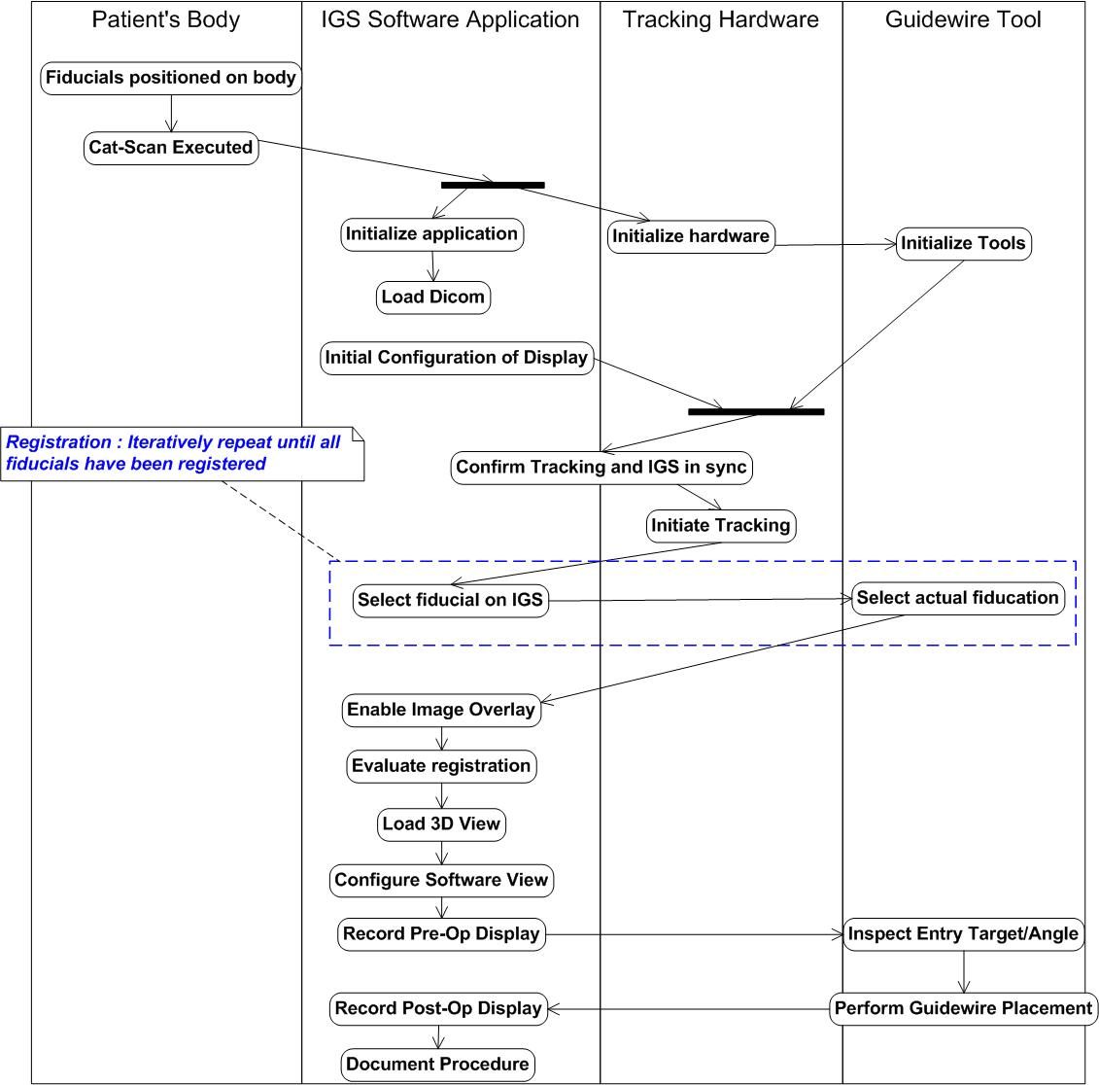
Figure 3. Activity Diagram Illustrating Guidewire Tracking Scenario.

IGSTK Quality Processes
    - Nightly dashboard
      - Unit test verification (not quite TDD)
      - Code coverage
      - Dynamic analysis
    - Quality processes on iteration boundaries
      - Code reviews
      - Sandbox (CM policy)
    - Architecture validation via SM path testing

Example Applications
An example application has been created to demonstrate the utility of the toolkit. This application is titled “FourViewTrackingWithCT” and the source code can be downloaded from the CVS repository as described earlier. A screenshot from the application is shown in Figure xx

The example application provides the basic functionality of an image-guided system: 1) the ability to read DICOM computed tomography (CT) images; 2) incorporation of an optical tracker (Polaris Vicra from Northern Digital, Inc.); 3) the ability to select fiducial points in CT space and tracker space; 4) paired point registration for determining the relationship between CT space and tracker space; and 5) the ability to provide image overlay by tracking surgical instruments and overlaying them on the anatomy from the CT images.

References:

Galloway, R. L., Jr. (2001). "The process and development of image-guided procedures." Annu Rev Biomed Eng 3: 83-108.

DICOM stands for Digital Imaging and Communications in Medicine and is a standard file format for medical images.

