
About ISIS | News Items | Research Programs | Tech Transfer | Faculty & Staff | Collaboration | Members Only | Contact Us
Welcome to ISIS | Research Overview | History | Management | Directions to ISIS
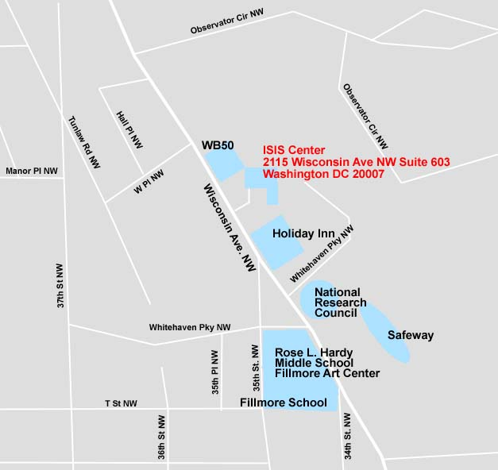

Georgetown University Medical Center
Department of Radiology, ISIS Center
2115 Wisconsin Avenue NW, Suite 603
Washington, DC 20007
Tel:(202)687-5990 / Fax:(202)784-3479

