IGSTK: Development Process and Project Management for an Open Source Software Toolkit for Image-Guided Surgery Applications
Kevin Cleary1, Brian Blake², Kevin Gary3, Julien Jommier4,
Stephen Aylward4, David Gobbi5, Hee-su Kim1, Rick Avila⁶, and Luis Ibanez6
1 Imaging Science and Information Systems (ISIS) Center, Department of Radiology, Georgetown University Medical Center, Washington, DC, 20007, USA
cleary@georgetown.edu, hkim@isis.imac.georgetown.edu
http://www.caimr.georgetown.edu/
2 Department of Computer Science, Georgetown University, Washington, DC, 20007, USA
blakeb@cs.georgetown.edu
3 Department of Computer Science, Arizona State University, Mesa, Arizona 85212, USA
kgary@asu.edu
4 Department of Radiology, University of North Carolina, Chapel Hill, NC, 27599, USA
jjomier@cs.unc.edu, aylward@unc.edu
5 Atamai Inc., London, Ontario, N6B 2R4, Canada
dgobbi@atamai.com
6 Kitware Inc., Clifton Park, NY, 12065, USA
rick.avila@kitware.com, luis.ibanez@kitware.com
Abstract. The abstract should summarize the contents of the paper and should contain at least 70 and at most 150 words. It should be set in 9-point font size and should be inset 1.0 cm from the right and left margins. There should be two blank (10-point) lines before and after the abstract. …

1 Introduction {Kevin Cleary draft 16 July 2005}
The image-guided software toolkit (IGSTK) is an open source project aimed at developing robust software for medical applications. Image-guided surgery involves the use of pre-operative medical images to provide image overlay and instrument guidance during the procedure. Image-guided surgery systems have been commercially available for about ten years now but this is still an active field of research and many researchers are developing prototype systems. These systems are software intensive and a lot of work is needed to develop the software for a prototype system. In addition, it is important that the software be robust and well-tested since it will be used in the medical environment.
The IGSTK project was designed to fill these needs. The toolkit contains the basic software components to construct an image-guided system including a tracker and a four-quadrant view incorporating image overlay. The highest priority in the design of the toolkit has been robustness and quality. The toolkit is based on the existing opening source components ITK, VTK, and FLTK.
Managing an open source project, particularly where multiple developers that are geographically distant are involved, is a challenge. A requirements-based software development process has been created in an attempt to satisfy the design goals of robustness and quality. A collaborative framework for project management has also been established using a Wiki environment.
This paper will describe our development process and project management for this effort. The paper will include an overview of the software development process including the use of multiple iterations and a project sandbox, the creation and tracking of requirements, and project management practices.

{pasted comments from Stephen here – I have no doubt Stephen can help edit this first section – can do now or wait until we see what Brian Blake and Kevin Gary write – 16 July 2005 – Kevin Cleary}

For paper 1,

I would emphasize requirements-based software development process. This has never been done before - it goes against ITK's style of programming.
It is a new style - combining extreme programming with requirements.
The sandbox makes this possible. My suggestion for the outline

Introduction
Need to assure software quality for image-guided interventions
- never in an unknown state
- only the necessary capabilities
- known performance / operating speeds
Solution: requirements-based software using open-source tools
Tools: vkt, fltk, itk, soviewers, trackerlib

Methods:
Usage cases
Requirements

Conflict with extreme programming

Use sandbox, iterations, and cvs checkin with requirements Also tcons, dashboards, etc.

Results
IGSTK is good....

2 Software Development Process
{Kevin Gary to write this section: overall philosophy, use of iterations, sandbox, etc}

2.1 Sample sub-header – just kept as a placeholder
Just in case anyone wants to break into subsections – but not sure we have room in a 4 page paper

2.2 Second sample sub-header- just a placeholder again
Just an example again

3 Requirements Definition and Tracking of Requirements
{Brian Blake to write this section – would be good to include a diagram of the requirements process}

{just an example figure and figure heading below}

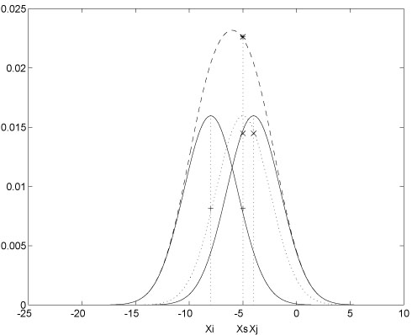
Fig. 1. One kernel at xs (dotted kernel) or two kernels at xi and xj (left and right) lead to the same summed estimate at xs. This shows a figure consisting of different types of lines. Elements of the figure described in the caption should be set in italics, in parentheses, as shown in this sample caption. The last sentence of a figure caption should generally end without a period

4 Project Management
{Kevin Gary to write this section: overall strategy, use of wiki, weekly tcons, etc}

References {example only – replace with ours}
1. Baldonado, M., Chang, C.-C.K., Gravano, L., Paepcke, A.: The Stanford Digital Library Metadata Architecture. Int. J. Digit. Libr. 1 (1997) 108–121
2. Bruce, K.B., Cardelli, L., Pierce, B.C.: Comparing Object Encodings. In: Abadi, M., Ito, T. (eds.): Theoretical Aspects of Computer Software. Lecture Notes in Computer Science, Vol. 1281. Springer-Verlag, Berlin Heidelberg New York (1997) 415–438
3. van Leeuwen, J. (ed.): Computer Science Today. Recent Trends and Developments. Lecture Notes in Computer Science, Vol. 1000. Springer-Verlag, Berlin Heidelberg New York (1995)
4. Michalewicz, Z.: Genetic Algorithms + Data Structures = Evolution Programs. 3rd edn. Springer-Verlag, Berlin Heidelberg New York (1996)

